**Secure Mail, embedded with SSL, Encryption,**

**Hashing and Salting**

*A project submitted*

*in partial fulfilment of the requirements for the degree of*

*Bachelor of Technology in Computer Science & Engineering*

**Infosys Limited**

#### Submitted By

Jaskaran Singh

(11501050)

**Supervised By**

Mr. Fazil A Khan



**PUNJABI UNIVERSITY, PATIALA**

**May 2019**

**PREFACE**

This work has been done as a part of industrial training. The purpose of the training is to become familiar with the present working environment in the companies.

We are provided with the opportunity to study the latest technical trends. The things I learnt during the period of industrial training will certainly help to boost my potential and technical skills.

As a part of our industrial training I undertook a project “**Secure Mail, embedded with SSL, Encryption, Hashing and Salting”**. It was a great learning experience I came across various problems and learnt many new things in the process to solve them.

I am pleased to present this project. Various software engineering concepts have been implemented. At last with all my gratitude I would like to thanks my colleagues and project guide for their help in the development of project.

Jaskaran Singh

B.tech (CE)

Roll no-11501050

**ACKNOWLEDGEMENT**

I am highly grateful to **Dr. Amardeep Singh,** Head of Department CSE for providing this opportunity to carry out the six month industrial training.

I would like to expresses my gratitude to other faculty members, for providing academic inputs, guidance & encouragement throughout the training period.

I would like to express a deep sense of gratitude and thank **Mr. Fazil Ahamed K,** Project mentorwithout whose permission, wise counsel and able guidance, it would have not been possible to pursue my training in this manner.

Finally, I express my indebtedness to all who have directly or indirectly contributed to the successful completion of my industrial training.

**UNDERTAKING**

I hereby declare that the project work entitled (**Secure Mail, embedded with SSL, Encryption, Hashing and Salting**) is an authentic record of my own work and is carried out as per the requirements for evaluation of six months project for the award of degree of B.TECH at Engineering Wing, Punjabi University, Patiala under the guidance of **Mr. Fazil Ahamed K.**

**Jaskaran Singh**

**ABSTRACT**

*Secured Mail main idea is to implement a mailing system inside organization with less cost and high security. This application will provide communication channel for employees clients and organization staff. Main intention of this application is to provide secure and cost efficient mailing system inside organization. Using this application companies can improve its overall performance of its system in the corporate sector.*

*Whenever user sends message to other person system will check whether the user is authorized or not. Message is forwarded to appropriate person. Based on the standard of message user will receive in respective folder.*

*Apart from normal mailing system features special security features are also included for security of user’s data as well as information. For security of password the concept of salting and hashing is used along with this the message is protected by encryption and decryption.*

***Existing System:***

*Earlier, when mailing was not available, postal system and telephone were the most omnipresent means to spread out notices. This was a very tedious, uneconomical, and time consuming task for consultancy offices But, with the inception of email, the traditional system has gone obsolete.*

***Proposed System:***

*Organisations, who are largely in need of a proper mailing list management system, can use this application to use it within organisation for internal mailing system between users and between user and admin .This can also be used to broadcast emails to users to notify them about some important event/details.*

*Another sound feature of the proposed system is that mailing lists can be created in the system database. This allows administrators to view available list of mailing addresses along with user profiles from the back end.*

***Modules Overview:***

*Mailing List system is a project built with two primary modules:*

***1. Administrators****: Administrator can manage, monitor and control the entire mailing list system. They can enable/disable the user and see user profiles and can delete the users from mailing list.*

***2. Users****: Users can send mail to the fellow users and other functionalities are provided to users such as delete mail , important, favourite, read/unread. Also ,user can be easily contacted by the admin via mail to notify them of something important.*

**TABLE OF CONTENTS**

|  |  |  |
| --- | --- | --- |
| **Sr. No.** | **TOPIC** | **Page No.** |
| **1.** | **PREFACE** | **2** |
| **2.** | **ACKNOWLEDGEMENT** | **3** |
| **3.** | **UNDERTAKING** | **4** |
| **4.** | **ABSTRACT** | **5** |
| **5.** | **LIST OF TABLES AND LIST OF FIGURES** | **7-8** |
| **6.** | **COMPANY PROFILE** | **9-10** |
| **7.** | **INTRODUCTION TO TECHNOLOGY** | **11-34** |
| **8.** | **INTRODUCTION TO PROJECT** | **35-38** |
| **9.** | **DATA FLOW DIAGRAMS** | **39-40** |
| **10.** | **DATABASE MODEL** | **41-42** |
| **11.** | **DATA DICTIONARY** | **43** |
| **12.** | **SCREENSHOTS** | **44-62** |
| **13.** | **CONCLUSION** | **63** |
| **14.** | **MAJOR CONTRIBUTIONS** | **64** |

|  |  |  |
| --- | --- | --- |
| **15** | **BIBLIOGRAPY** | **65** |

**LIST OF TABLES**

Table 1 Versions of Java……………………………………………………...16

Table 2 Project Modules………………………………………………………31

Table 3 User’s Database ……………………………………………………...39

Table 4 Content database………………………………………………………39

**LIST OF FIGURES**

Figure 1 Features of Java……………………………………………………....10

Figure 2 Bytecode………………………………………………….…………....11

Figure 3 Virtual machines sandbox……………………….…………………...12

Figure 4 Java architecture……………………………………………………...13

Figure 5 java compilation process…………………………..………………...14

Figure 6 detailed java architecture……………………..…………………...15

Figure 7 hashing ……………………………………………………….………...26

Figure 8 encryption and decryption……………………..…………………....27

Figure 9 aes algorithm……………………………………….…………….…...29

Figure 10 User functionalities ……………………………..………………...33

Figure 11 Admin functionalities ……………………………..………………..34

Figure 12.i DFD Level 0…………………………………………………………..35

Figure 12.ii DFD Level 1…………………………………………………………..35

Figure 12.iii DFD Level 2……………………………………………..…………..36

Figure 13 .i ER Diagram (User)…………………...……………………………..37

Figure 13.ii ER Diagram (Admin)………………………………………………..38

**COMPANY PROFILE**

**Infosys Limited** (formerly Infosys Technologies Limited) is an Indian multinational corporation that provides business consulting, information technology and outsourcing services. It has its headquarters in Bengaluru, India.

Infosys is the second-largest Indian IT services company by 2016 revenues, and the largest employer of H-1B visa professionals in the United States. On January 12, 2017, its market capitalisation was $34.38 Billion.

Co-founded in 1981 by 7 Engineers N. R. Narayana Murthy, Nandan Nilekani, N. S. Raghavan, S. Gopalakrishnan, S. D. Shibulal, K. Dinesh and Ashok Arora after they resigned from Patni Computer Systems. The company was incorporated as "Infosys Consultants Pvt Ltd."

The Company changed its name to "Infosys Technologies Private Limited" in April 1992 and to "Infosys Technologies Limited" when it became a public limited company in June 1992. It was later renamed to "Infosys Limited" in June 2011.

On 15 January 2016, Infosys had 1,045 clients across 50 countries.

Infosys has a global footprint with offices and development centres across the world.

In 2012, Infosys announced a new office in Milwaukee, Wisconsin to service Harley-Davidson, being the 18th international office in the United States. Infosys hired 1,200 United States employees in 2011,and expanded the workforce by an additional 2,000 employees in 2012.

It provides software development, maintenance and independent validation services to companies in banking, finance, insurance, manufacturing and other domains.

As the world's largest corporate university, the Infosys global education centre in the 337-acre campus has 400 instructors and 200 classrooms, with international benchmarks at its core. Established in 2002, it had trained around 125,000 engineering graduates by June 2015. It can train 14,000 employees at a given point of time on various technologies.

The Infosys Leadership Institute (ILI), based in Mysore, has 96 rooms and trains about 400 Infoscians annually.

Our organization is not only about technology, also about our people and their professional growth. We hire eager, educated and determined innovators that are fully dedicated towards developing our client's success. We favour ability over experience and provide extensive training for all new employees. Our work environment is fast paced, challenging and a whole lot of fun.

In 1996, Infosys established the Infosys Foundation, to support the underprivileged sections of society. At the outset, the Infosys Foundation implemented many programs in Karnataka. It subsequently covered Tamil Nadu, Telangana, Andhra Pradesh, Maharashtra, Odisha, and Punjab in a phased manner. A team at the Foundation identifies all the programs in the areas of Healthcare, Education, Culture, Destitute Care and Rural Development.

Infosys Global Academic Relations team forges Academic Entente (AcE) [clarification needed] with academic and partner institutions. It explores co-creation opportunities between Infosys and academia through case studies, student trips and speaking engagements. They also collaborate on technology, emerging economies, globalization, and research. Some initiatives include research collaborations, publications, conferences and speaking sessions, campus visits and campus hiring.

Infosys Labs collaborates with leading national and international universities such as the University of Southern California Viterbi School of Engineering, University of Cambridge, Queens University of Belfast, University of Illinois at Urbana-Champaign, Indian Institute of Technology Bombay, IITB-Monash Research Academy, Indraprastha Institute of Information Technology, Delhi, Indian Institute of Science, Bangalore, Purdue University, [46] Indian Institute of Information Technology, Bangalore.

In December 2003, Infosys had acquired Australia-based IT service provider Expert Information Services for $23 million.

In December 2009, [Infosys BPO](https://en.wikipedia.org/wiki/Infosys_BPO_Limited#Acquisitions) acquired Atlanta-based McCamish Systems for about $38 million.

In January 2012, Infosys BPO acquired Australia-based Portland Group, provider of strategic sourcing and category management services, for about AUD 37 million.

In September 2012, Infosys acquired Switzerland-based [Lodestone Management Consultants](https://en.wikipedia.org/wiki/Lodestone_Management_Consultants) for about $345 million.

In March 2015, Infosys acquired Panaya, Inc., a leading provider of automation technology for large scale enterprise software management.

In June 2015, Infosys acquired Skava, a leading provider of digital experience solutions, including mobile commerce and in-store shopping experiences to large retail clients.

In November 2015, Infosys acquired Noah-Consulting, a provider of information management consulting services for the oil and gas industry, based out of Houston, Texas, USA.

In Aug 2017, Infosys acquired UK based Breilliant Basics.

In the year 2019, Infosys acquired USA based WongDoody (Jan) and Netherland based Stater(Apr).

**Introduction To Technologies Worked On**

**JAVA**

**Introduction**

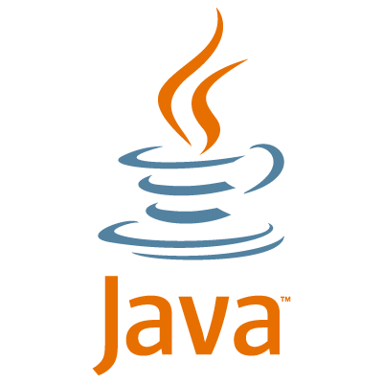

Java is a simple and yet powerful object oriented programming language and it is in many respects similar to C++. Java was originated at Sun Microsystems, Inc. in 1991. It was conceived by James Gosling, Patrick Naughton, Chris Warth, Ed Frank, and Mike Sheridan at Sun Microsystems, Inc. It was developed to provide a platform-independent programming language. This site gives you an Introduction to Java Programming accompanied with many java examples. It’s a complete course in java programming for beginners to advanced java.

Like any programming language, the Java language has its own structure, syntax rules, and programming paradigm. The Java language's programming paradigm is based on the concept of OOP, which the language's features support.

The Java language is a C-language derivative, so its syntax rules look much like C's. For example, code blocks are modularized into methods and delimited by braces ({ and }), and variables are declared before they are used.

Structurally, the Java language starts with *packages*. A package is the Java language's namespace mechanism. Within packages are classes, and within classes are methods, variables, constants, and more. You learn about the parts of the Java language in this tutorial.

## Features of java

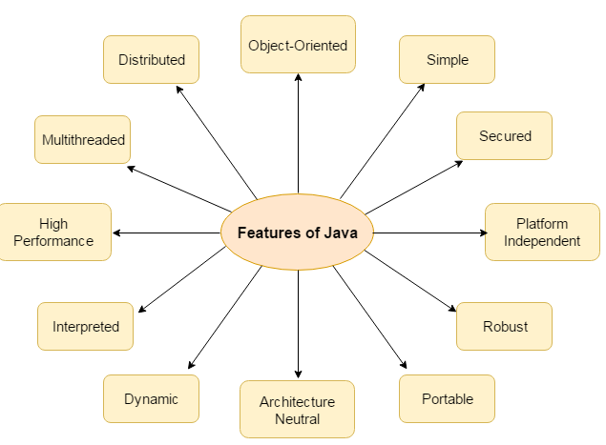

**(Fig 1)**

There are many features of java. They are also known as java buzzwords. The Java Features (Fig 1) given below are simple and easy to understand.

#### Simple:

Java is easy to learn and its syntax is quite simple, clean and easy to understand. The confusing and ambiguous concepts of C++ are either left out in Java or they have been re-implemented in a cleaner way. *Eg :* Pointers and Operator Overloading are not there in java but were an important part of C++.

#### Object Oriented:

#### In java everything is Object which has some data and behaviour. Java can be easily extended as it is based on Object Model.

#### Robust:

#### Java makes an effort to eliminate error prone codes by emphasizing mainly on compile time error checking and runtime checking. But the main areas which Java improved were Memory Management and mishandled Exceptions by introducing automatic Garbage Collector and Exception Handling.

#### Platform Independent:

Unlike other programming languages such as C, C++ etc which are compiled into platform specific machines. Java is guaranteed to be write-once, run-anywhere language.

On compilation Java program is compiled into bytecode. This bytecode is platform independent and can be run on any machine, plus this bytecode format also provide security. Any machine with Java Runtime Environment can run Java Programs.

#### C:\Users\djyoshnareddy.trn\Documents\3.PNG

(Fig 2)

#### Secure:

When it comes to security, Java is always the first choice. With java secure features it enable us to develop virus free, temper free system. Java program always runs in Java runtime environment with almost null interaction with system OS, hence it is more secure.

* **Classloader:** adds security by separating the package for the classes of the local file system from those that are imported from network sources.
* **Bytecode Verifier:** checks the code fragments for illegal code that can violate access right to objects.
* **Security Manager:** determines what resources a class can access such as reading and writing to the local disk.

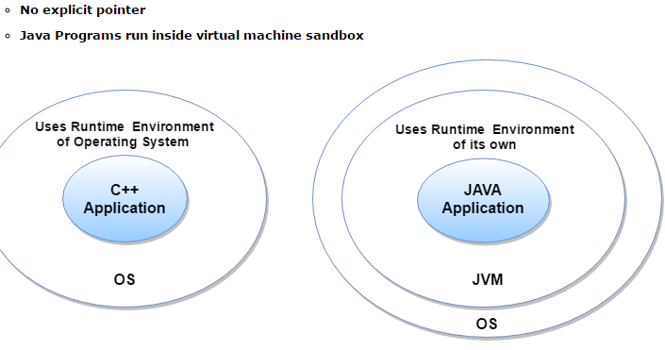

(Fig 3)

#### Multi Threading:

Java multithreading feature makes it possible to write program that can do many tasks simultaneously. Benefit of multithreading is that it utilizes same memory and other resources to execute multiple threads at the same time, like While typing, grammatical errors are checked along.

#### Architectural Neutral:

Java Byte code can be carried to any platform. No implementation dependent features. Everything related to storage is predefined, example: size of primitive data types.

#### High Performance:

Java is an interpreted language, so it will never be as fast as a compiled language like C or C++. But, Java enables high performance with the use of just-in-time compiler.

### New Features of JAVA 8

Below mentioned are some of the core upgrades done as a part of Java 8 release. Just go through them quickly, we will explore them in details later.

* Enhanced Productivity by providing Optional Classes feature, Lamda Expressions, Streams etc.
* Ease of Use
* Improved Polyglot programming. A **Polyglot** is a program or script, written in a form which is valid in multiple programming languages and it performs the same operations in multiple programming languages. So Java now supports such type of programming technique.

**Java Architecture:**

**1. Compilation and interpretation in Java**

Java combines both the approaches of compilation and interpretation. First, java compiler compiles the source code into byte code. At the run time, Java Virtual Machine (JVM) interprets this byte code and generates machine code which will be directly executed by the machine in which java program runs. So java is both compiled and interpreted language.

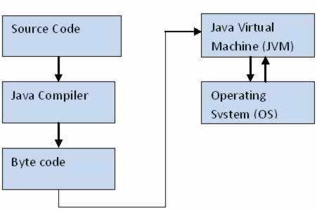

(Fig 4)

**2. Java Virtual Machine (JVM)**

JVM is a component which provides an environment for running Java programs. JVM interprets the byte code into machine code which will be executed the machine in which the Java program runs.

**3. Why Java is Platform Independent?**

Platform independence is one of the main advantages of Java. In another words, java is portable because the same java program can be executed in multiple platforms without making any changes in the source code. You just need to write the java code for one platform and the same program will run in any platforms. But how does Java make this possible?

As we discussed early, first the Java code is compiled by the Java compiler and generates the byte code.  This byte code will be stored in class files**.**Java Virtual Machine (JVM) is unique for each platform.   Though JVM is unique for each platform, all interpret the same byte code and convert it into machine code required for its own platform and this machine code will be directly executed by the machine in which java program runs.  This makes Java platform independent and portable.

Let’s make it more clear with the help of the following diagram.  Here the same compiled Java byte code is interpreted by two different JVMS to make it run in Windows and Linux platforms.

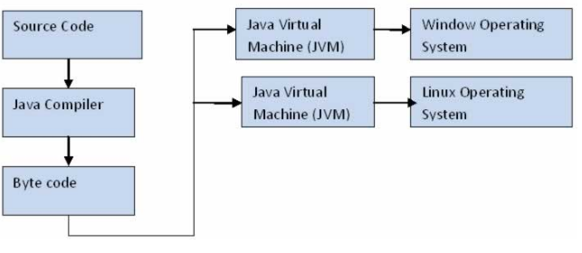

(Fig 5)

**4. Java Runtime Environment (JRE) and Java Architecture in Detail**

Java Runtime Environment contains JVM, class libraries and other supporting components.

As you know the Java source code is compiled into byte code by Java compiler. This byte code will be stored in class files. During runtime, this byte code will be loaded, verified and   JVM interprets the byte code into machine code which will be executed in the machine in which the Java program runs.

A Java Runtime Environment performs the following main tasks respectively.

1. Loads the class

This is done by the class loader

2. Verifies the byte code

This is done by byte code verifier.

3. Interprets the byte code

This is done by the JVM

These tasks are described in detail in the subsequent sessions. A detailed Java architecture can be drawn as given below.

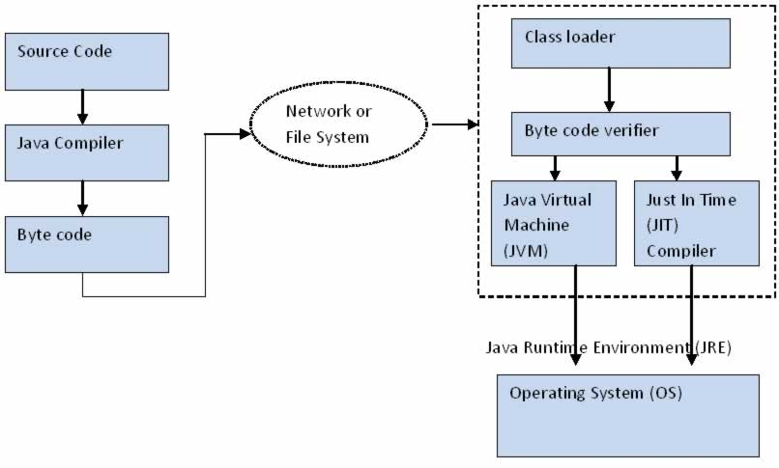

(Fig 6)

#### History of Java

Java history is interesting to know. The history of java starts from Green Team. Java team members (also known as Green Team), initiated a revolutionary task to develop a language for digital devices such as set-top boxes, televisions etc.

For the green team members, it was an advance concept at that time. But, it was suited for internet programming. Later, Java technology as incorporated by Netscape.

Currently, Java is used in internet programming, mobile devices, games, e-business solutions etc. There are given the major points that describes the history of java.

1) **James Gosling**, **Mike Sheridan**, and **Patrick Naughton** initiated the Java language project in June 1991. The small team of sun engineers called **Green Team**.

2) Originally designed for small, embedded systems in electronic appliances like set-top boxes.

3) Firstly, it was called **"Greentalk"** by James Gosling and file extension was .gt.

4) After that, it was called **Oak** and was developed as a part of the Green project.

**Versions**

|  |  |  |
| --- | --- | --- |
| **VVVersion Number** | **IiIntial Year** | **Code Name** |
| **JDK Beta** | 1994 |  |
| **JDK 1.0** | 1996 | OAK |
| **JDK 1.1** | 1997 | ------ |
| **J2SE 1.2** | 1998 | PLAY GROUND |
| **J2SE 1.3** | 2000 | KESTROL |
| **J2SE 1.4** | 2002 | MERLIN |
| **J2SE 5.0** | 2005 | TIGER |
| **JAVA SE 6** | 2006 | MUSTANG |
| **JAVA SE 7** | 2011 | DOLPHIN |
| **JAVA SE 8** | 2014 | ------ |

(Table 1)

**HTML5**

**HTML5** is a [markup language](https://en.wikipedia.org/wiki/Markup_language) used for structuring and presenting content on the [World Wide Web](https://en.wikipedia.org/wiki/World_Wide_Web). It is the fifth and current version of the [HTML](https://en.wikipedia.org/wiki/HTML) standard.

It was published in October 2014 by the [World Wide Web Consortium](https://en.wikipedia.org/wiki/World_Wide_Web_Consortium) (W3C) to improve the language with support for the latest multimedia, while keeping it both easily readable by humans and consistently understood by computers and devices such as [web browsers](https://en.wikipedia.org/wiki/Web_browser), [parsers](https://en.wikipedia.org/wiki/Parsing), etc. HTML5 is intended to subsume not only [HTML 4](https://en.wikipedia.org/wiki/HTML_4), but also [XHTML](https://en.wikipedia.org/wiki/XHTML) 1 and [DOM Level 2 HTML](https://en.wikipedia.org/wiki/Document_Object_Model).

HTML5 includes detailed processing models to encourage more interoperable implementations; it extends, improves and rationalizes the markup available for documents, and introduces markup and [application programming interfaces](https://en.wikipedia.org/wiki/Application_programming_interfaces) (APIs) for complex [web applications](https://en.wikipedia.org/wiki/Web_application). For the same reasons, HTML5 is also [a candidate for cross-platform mobile applications](https://en.wikipedia.org/wiki/HTML5_in_mobile_devices), because it includes features designed with low-powered devices in mind.

**Logo**



On 18 January 2011, the W3C introduced a logo to represent the use of or interest in HTML5. Unlike other badges previously issued by the W3C, it does not imply validity or conformance to a certain standard. As of 1 April 2011, this logo is official.

When initially presenting it to the public, the W3C announced the HTML5 logo as a "general-purpose visual identity for a broad set of open web technologies, including HTML5, [CSS](https://en.wikipedia.org/wiki/Cascading_Style_Sheets), SVG, [WOFF](https://en.wikipedia.org/wiki/Web_Open_Font_Format), and others". Some web standard advocates, including The Web Standards Project, criticized that definition of "HTML5" as an umbrella term, pointing out the blurring of terminology and the potential for miscommunication. Three days later, the W3C responded to community feedback and changed the logo's definition, dropping the enumeration of related technologies. The W3C then said the logo "represents HTML5, the cornerstone for modern Web applications".

**Features:-**

### Markup

HTML5 introduces [elements](https://en.wikipedia.org/wiki/HTML_element) and attributes that reflect typical usage on modern [websites](https://en.wikipedia.org/wiki/Website). Some of them are semantic replacements for common uses of generic block (<div>) and inline (<span>) elements, for example <nav> (website navigation block), <footer> (usually referring to bottom of web page or to last lines of HTML code), of <object>. Some deprecated elements from [HTML 4.01](https://en.wikipedia.org/wiki/HTML_4.01) have been dropped, including purely presentational elements such as <font> and <center>, whose effects have long been superseded by the more capable [Cascading Style Sheets](https://en.wikipedia.org/wiki/Cascading_Style_Sheet). There is also a renewed emphasis on the importance of [DOM scripting](https://en.wikipedia.org/wiki/DOM_scripting) (e.g., JavaScript) in Web behavior.

The HTML5 syntax is no longer based on [SGML](https://en.wikipedia.org/wiki/Standard_Generalized_Markup_Language) despite the similarity of its markup. It has, however, been designed to be backward compatible with common parsing of older versions of HTML. It comes with a new introductory line that looks like an SGML [document type declaration](https://en.wikipedia.org/wiki/Document_type_declaration), <!DOCTYPE html>, which triggers the standards-compliant [rendering mode](https://en.wikipedia.org/wiki/Quirks_mode). Since 5 January 2009, HTML5 also includes Web Forms 2.0, a previously separate [WHATWG](https://en.wikipedia.org/wiki/WHATWG) specification.

**HTML5 related APIs**

In addition to specifying markup, HTML5 specifies scripting [application programming interfaces](https://en.wikipedia.org/wiki/Application_programming_interfaces) (APIs) that can be used with JavaScript. Existing [document object model](https://en.wikipedia.org/wiki/Document_object_model) (DOM) interfaces are extended and [de facto](https://en.wikipedia.org/wiki/De_facto) features documented. There are also new APIs, such as:

* [Canvas](https://en.wikipedia.org/wiki/Canvas_element);
* Timed Media Playback;
* Offline;
* Editable content;
* [Drag-and-drop](https://en.wikipedia.org/wiki/Drag-and-drop);
* History;
* [MIME type](https://en.wikipedia.org/wiki/MIME_type) and protocol handler registration;
* [Microdata](https://en.wikipedia.org/wiki/Microdata_(HTML));
* [Web Messaging](https://en.wikipedia.org/wiki/Web_Messaging);
* [Web Storage](https://en.wikipedia.org/wiki/Web_Storage) – a key-value pair storage framework that provides behaviour similar to [cookies](https://en.wikipedia.org/wiki/HTTP_Cookie) but with larger storage capacity and improved API.

Not all of the above technologies are included in the W3C HTML5 specification, though they are in the WHATWG HTML specification. Some related technologies, which are not part of either the W3C HTML5 or the WHATWG HTML specification, are as follows. The W3C publishes specifications for these separately:

* [Geolocation](https://en.wikipedia.org/wiki/W3C_Geolocation_API);
* [Web SQL Database](https://en.wikipedia.org/wiki/Web_SQL_Database) – a local SQL Database (no longer maintained);
* [IndexedDB](https://en.wikipedia.org/wiki/IndexedDB) – an indexed hierarchical key-value store (formerly WebSimpleDB);
* [File](https://en.wikipedia.org/wiki/HTML5_File_API) – an API intended to handle file uploads and file manipulation;
* Directories and System – an API intended to satisfy client-side-storage use cases not well served by databases;
* File Writer – an API for writing to files from web applications;
* [Web Audio](https://en.wikipedia.org/wiki/HTML5_Audio#Web_Audio_API_and_MediaStream_Processing_API) – a high-level JavaScript API for processing and synthesizing audio in web applications;
* ClassList.
* [Web Cryptography](https://en.wikipedia.org/w/index.php?title=Web_Cryptography&action=edit&redlink=1)

**CSS (Cascading Style Sheets):**

**CSS** is a [style sheet language](https://en.wikipedia.org/wiki/Style_sheet_language) used for describing the presentation of a document written in a [markup language](https://en.wikipedia.org/wiki/Markup_language). Although most often used to set the visual style of [web pages](https://en.wikipedia.org/wiki/Web_page) and user interfaces written in [HTML](https://en.wikipedia.org/wiki/HTML) and [XHTML](https://en.wikipedia.org/wiki/XHTML), the language can be applied to any [XML](https://en.wikipedia.org/wiki/XML) document, including [plain XML](https://en.wikipedia.org/wiki/Plain_Old_XML), [SVG](https://en.wikipedia.org/wiki/Scalable_Vector_Graphics) and [XUL](https://en.wikipedia.org/wiki/XUL), and is applicable to rendering in [speech](https://en.wikipedia.org/wiki/Speech_synthesis), or on other media. Along with HTML and [JavaScript](https://en.wikipedia.org/wiki/JavaScript), CSS is a cornerstone technology used by most websites to create visually engaging webpages, user interfaces for [web applications](https://en.wikipedia.org/wiki/Web_applications), and user interfaces for many mobile applications.

CSS is designed primarily to enable the separation of presentation and content, including aspects such as the [layout](https://en.wikipedia.org/wiki/Page_layout), [colors](https://en.wikipedia.org/wiki/Color), and [fonts](https://en.wikipedia.org/wiki/Typeface). This separation can improve content [accessibility](https://en.wikipedia.org/wiki/Accessibility), provide more flexibility and control in the specification of presentation characteristics, enable multiple HTML pages to share formatting by specifying the relevant CSS in a separate .css file, and reduce complexity and repetition in the structural content.

Separation of formatting and content makes it possible to present the same markup page in different styles for different rendering methods, such as on-screen, in print, by voice (via speech-based browser or [screen reader](https://en.wikipedia.org/wiki/Screen_reader)), and on [Braille-based](https://en.wikipedia.org/wiki/Braille_display) tactile devices. It can also display the web page differently depending on the screen size or viewing device. Readers can also specify a different style sheet, such as a CSS file stored on their own computer, to override the one the author specified.

Changes to the [graphic design](https://en.wikipedia.org/wiki/Graphic_design) of a document can be applied quickly and easily, by editing a few lines in the CSS file they use, rather than by changing markup in the documents.

**Advantages**

**Separation of content from presentation**

CSS facilitates publication of content in multiple presentation formats based on nominal parameters. Nominal parameters include explicit user preferences, different web browsers, the type of device being used to view the content (a desktop computer or mobile Internet device), the geographic location of the user and many other variables.

**Bandwidth**

A stylesheet, internal or external, specifies the style once for a range of HTML elements selected by class, type or relationship to others. This is much more efficient than repeating style information inline for each occurrence of the element. An external stylesheet is usually stored in the [browser cache](https://en.wikipedia.org/wiki/Browser_cache), and can therefore be used on multiple pages without being reloaded, further reducing data transfer over a network.

**Page reformatting**

With a simple change of one line, a different style sheet can be used for the same page. This has advantages for accessibility, and providing the ability to tailor a page or site to different target devices. Also, devices not able to understand the styling still display the content.

**Accessibility**

Without CSS, web designers must typically lay out their pages with techniques such as HTML tables that hinder accessibility for vision-impaired users.

**ANGULAR 4**

Angular 4 is a JavaScript framework for building web applications and apps in JavaScript, html, and TypeScript, which is a superset of JavaScript. Angular provides built-in features for animation, http service, and materials which in turn has features such as auto-complete, navigation, toolbar, menus, etc. The code is written in TypeScript, which compiles to JavaScript and displays the same in the browser.

The structure of Angular is based on the components/services architecture. AngularJS was based on the model view controller. Angular 4 released in March 2017

These are the core building blocks of Angular 4:

* **Modules** which group or encapsulate functionality within the application
* **Components** which represent a unified View + View Model + Styles unit that you can compose to create an application
* **Templates** which represent a view with a special syntax to enhance html with Angular4
* **Metadata** that wires everything together, a view with a view model with styles, etc
* **Data Binding** to flow data changes between view and view model and vice versa
* **Services** to encapsulate and reuse non-view related logic that can be used by different parts of an application
* **Directives**
* **Dependency Injection** to inject the necessary dependencies for a given component/service at runtime and provide flexibility, extensibility and testability.

The Angular 4 folder has the following folder structure −

* **e2e** − end to end test folder. Mainly e2e is used for integration testing and helps ensure the application works fine.
* **node_modules** − The npm package installed is node_modules. You can open the folder and see the packages available.
* **src** − This folder is where we will work on the project using Angular 4.

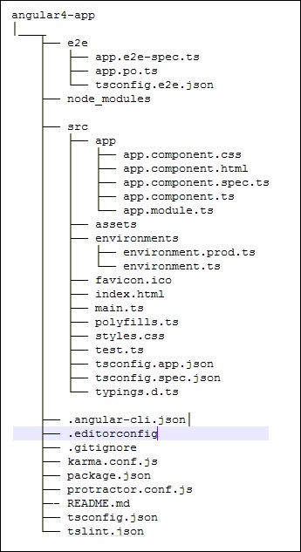

The Angular 4 app folder has the following **file structure** −

* **.angular-cli.json** − It basically holds the project name, version of cli, etc.
* **.editorconfig** − This is the config file for the editor.
* **karma.conf.js** − This is used for unit testing via the protractor. All the information required for the project is provided in karma.conf.js file.
* **package.json** − The package.json file tells which libraries will be installed into node_modules when you run npm install.

### App

It contains the files described below. These files are installed by angular-cli by default.

* **app.module.ts** − If you open the file, you will see that the code has reference to different libraries, which are imported. Angular-cli has used these default libraries for the import – angular/core, platform-browser.

They are imported and saved into variables such as declarations, imports, providers, and bootstrap.

**Declarations** − In declarations, the reference to the components is stored. The Appcomponent is the default component that is created whenever a new project is initiated. We will learn about creating new components in a different section.

**Imports** − This will have the modules imported as shown above. At present, BrowserModule is part of the imports which is imported from @angular/platform-browser.

**Providers** − This will have reference to the services created.

**Bootstrap** − This has reference to the default component created, i.e., AppComponent

* app.component.css
* app.component.html
* app.component.spec.ts − These are automatically generated files which contain unit tests for source component.
* app.component.ts − The class for the component is defined over here. You can do the processing of the html structure in the .ts file. The processing will include activities such as connecting to the database, interacting with other components, routing, services, etc.

### Assets

You can save your images, js files in this folder.

### Environment

This folder has the details for the production or the dev environment. The folder contains two files.

* environment.prod.ts
* environment.ts

Both the files have details of whether the final file should be compiled in the production environment or the dev environment.

### favicon.ico

This is a file that is usually found in the root directory of a website.

### index.html

This is the file which is displayed in the browser.

### main.ts

main.ts is the file from where we start our project development. It starts with importing the basic module which we need.

**Features**

* **Progressive web apps:** It uses modern web platform capabilities to deliver an app-like experience. It gives high performance, offline, and zero-step installation. So, working with Angular is pretty much easy.
* **Desktop**: Create desktop-installed apps across Mac, Windows, and Linux using the same Angular methods you’ve learned for the web plus
* **Code generation**: Angular turns your templates into code that’s highly optimized for JavaScript
* **Universal:** You can use any technology with Angular for serving the application like node.js, .NET, PHP and other servers.
* **Code splitting**: Angular apps load quickly with the new Component Router, which delivers automatic code-splitting, so users only load code required to render the view they request.
* **Testing**: You can identify your mistake on the fly and Protractor makes your scenario tests run faster and in a stable manner.

**Bootstrap:**

Bootstrap is a powerful front-end framework for faster and easier web development. It includes HTML and CSS based design templates for common user interface components like Typography, Forms, Buttons, Tables, Navigations, Dropdowns, Alerts, Modals, Tabs, Accordion, Carousel and many other as well as optional JavaScript extensions.

Bootstrap also gives you ability to create responsive layout with much less efforts.

## Advantages of Bootstrap:

The biggest advantage of using Bootstrap is that it comes with free set of tools for creating flexible and responsive web layouts as well as common interface components.

Additionally, using the Bootstrap data APIs you can create advanced interface components like Scrollspy and Type aheads without writing a single line of JavaScript.

Here are some more advantages, why one should opt for Bootstrap:

* **Save lots of time** — You can save lots of time and efforts using the Bootstrap predefined design templates and classes and concentrate on other development work.
* **Responsive features** — Using Bootstrap you can easily create responsive designs. Bootstrap responsive features make your web pages to appear more appropriately on different devices and screen resolutions without any change in markup.
* **Consistent design** — All Bootstrap components share the same design templates and styles through a central library, so that the designs and layouts of your web pages are consistent throughout your development.
* **Easy to use** — Bootstrap is very easy to use. Anybody with the basic working knowledge of HTML and CSS can start development with Bootstrap.
* **Compatible with browsers** — Bootstrap is created with modern browsers in mind and it is compatible with all modern browsers such as Mozilla Firefox, Google Chrome, Safari, Internet Explorer, and Opera.
* **Open Source** — And the best part is, it is completely free to download and use

**Hibernate:**

Hibernate is an **O**bject-**R**elational **M**apping (ORM) solution for JAVA. It is an open source persistent framework created by Gavin King in 2001. It is a powerful, high performance Object-Relational Persistence and Query service for any Java Application.

Hibernate maps Java classes to database tables and from Java data types to SQL data types and relieves the developer from 95% of common data persistence related programming tasks.

Hibernate sits between traditional Java objects and database server to handle all the works in persisting those objects based on the appropriate O/R mechanisms and patterns.

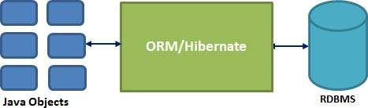

Hibernate requires to know in advance — where to find the mapping information that defines how your Java classes relate to the database tables. Hibernate also requires a set of configuration settings related to database and other related parameters. All such information is usually supplied as a standard Java properties file called **hibernate.properties**, or as an XML file named **hibernate.cfg.xml**.

**Hibernate Advantages:**

* Hibernate takes care of mapping Java classes to database tables using XML files and without writing any line of code.
* Provides simple APIs for storing and retrieving Java objects directly to and from the database.
* If there is change in the database or in any table, then you need to change the XML file properties only.
* Abstracts away the unfamiliar SQL types and provides a way to work around familiar Java Objects.
* Hibernate does not require an application server to operate.
* Manipulates Complex associations of objects of your database.
* Minimizes database access with smart fetching strategies.
* Provides simple querying of data.

**Hibernate Session:**

A Session is used to get a physical connection with a database. The Session object is lightweight and designed to be instantiated each time an interaction is needed with the database. Persistent objects are saved and retrieved through a Session object.

The session objects should not be kept open for a long time because they are not usually thread safe and they should be created and destroyed them as needed. The main function of the Session is to offer, create, read, and delete operations for instances of mapped entity classes.

Instances may exist in one of the following three states at a given point in time −

* **Transient** − A new instance of a persistent class, which is not associated with a Session and has no representation in the database and no identifier value is considered transient by Hibernate.
* **Persistent** − You can make a transient instance persistent by associating it with a Session. A persistent instance has a representation in the database, an identifier value and is associated with a Session.
* **Detached** − Once we close the Hibernate Session, the persistent instance will become a detached instance.

**Hibernate - Query Language:**

Hibernate Query Language (HQL) is an object-oriented query language, similar to SQL, but instead of operating on tables and columns, HQL works with persistent objects and their properties. HQL queries are translated by Hibernate into conventional SQL queries, which in turns perform action on database.

Although you can use SQL statements directly with Hibernate using Native SQL, but I would recommend to use HQL whenever possible to avoid database portability hassles, and to take advantage of Hibernate's SQL generation and caching strategies.

Keywords like SELECT, FROM, and WHERE, etc., are not case sensitive, but properties like table and column names are case sensitive in HQL.

**COOKIES:**

**Cookies** are text files stored on the client computer and they are kept for various information tracking purpose. **Java** Servlets transparently supports HTTP **cookies**. Server script sends a set of **cookies** to the browser. A **cookie** is a small piece of information that is persisted between the multiple client requests. A cookie has a name, a single value, and optional attributes.

### How Cookie works:

By default, each request is considered as a new request. In cookies technique, we add cookie with response from the servlet. So cookie is stored in the cache of the browser. After that if request is sent by the user, cookie is added with request by default. Thus, we recognize the user as the old user.

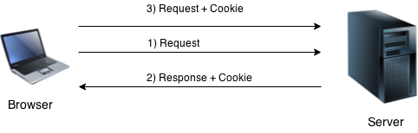

### Types of Cookie:

There are 2 types of cookies in servlets.

* **Non-persistent cookie:**

It is **valid for single session** only. It is removed each time when user closes the browser.

### Persistent cookie:

It is **valid for multiple session**. It is not removed each time when user closes the browser. It is removed only if user logout or sign out.

### Advantage of Cookies:

1. Simplest technique of maintaining the state.
2. Cookies are maintained at client side.

### Disadvantage of Cookies:

1. It will not work if cookie is disabled from the browser.
2. Only textual information can be set in Cookie object.

**Concepts used in project:**

* **Salting:**

In cryptography, a salt is random data that is used as an additional input to a

one-way function that "hashes" data, a password or passphrase. Salts are used to safeguard passwords in storage. Historically a password was stored in plaintext on a system, but over time additional safeguards developed to protect a user's password against being read from the system. A salt is one of those methods.

A new salt is randomly generated for each password. In a typical setting the salt and the password (or its version after Key stretching) are concatenated and processed with a cryptographic hash function, and the resulting output (but not the original password) is stored with the salt in a database. Hashing allows for later authentication without keeping and therefore risking the plaintext password in the event that the authentication data store is compromised.

* **Hashing:**

A **hash function** is any [function](https://en.wikipedia.org/wiki/Function_(mathematics)) that can be used to map [data](https://en.wikipedia.org/wiki/Data_(computing)) of arbitrary size onto data of a fixed size. The values returned by a hash function are called **hash values**, **hash codes**, **digests**, or simply **hashes**. Hash functions are often used in combination with a [hash table](https://en.wikipedia.org/wiki/Hash_table), a common [data structure](https://en.wikipedia.org/wiki/Data_structure) used in computer software for rapid data lookup. Hash functions accelerate table or database lookup by detecting duplicated records in a large file. This is used for assuring [integrity](https://en.wikipedia.org/wiki/Data_integrity) of transmitted data, and is the building block for [HMACs](https://en.wikipedia.org/wiki/Hash-based_message_authentication_code), which provide [message authentication](https://en.wikipedia.org/wiki/Message_authentication).

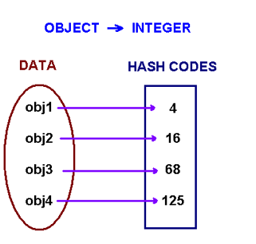

(Fig 7)

* **Encryption**

In [cryptography](https://en.wikipedia.org/wiki/Cryptography), **encryption** is the process of encoding a message or information in such a way that only authorized parties can access it and those who are not authorized cannot. Encryption does not itself prevent interference, but denies the intelligible content to a would-be interceptor. In an encryption scheme, the intended information or message, referred to as [plaintext](https://en.wikipedia.org/wiki/Plaintext), is encrypted using an encryption algorithm – a [cipher](https://en.wikipedia.org/wiki/Cipher) – generating [ciphertext](https://en.wikipedia.org/wiki/Ciphertext) that can be read only if decrypted. For technical reasons, an encryption scheme usually uses a [pseudo-random](https://en.wikipedia.org/wiki/Pseudo-random) encryption key generated by an algorithm. It is in principle possible to decrypt the message without possessing the key, but, for a well-designed encryption scheme, considerable computational resources and skills are required. An authorized recipient can easily decrypt the message with the [key](https://en.wikipedia.org/wiki/Key_(cryptography)) provided by the originator to recipients but not to unauthorized users.

* **Decryption**

The conversion of encrypted data into its original form is called Decryption. It is generally a reverse process of encryption. It decodes the encrypted information so that an authorized user can only decrypt the data because decryption requires a secret key.  
For decryption, the system extracts and converts the garbled data and transforms it into words and images that are easily understandable not only by a reader but also by a system. Decryption can be done manually or automatically. It may also be performed with a set of keys or passwords.

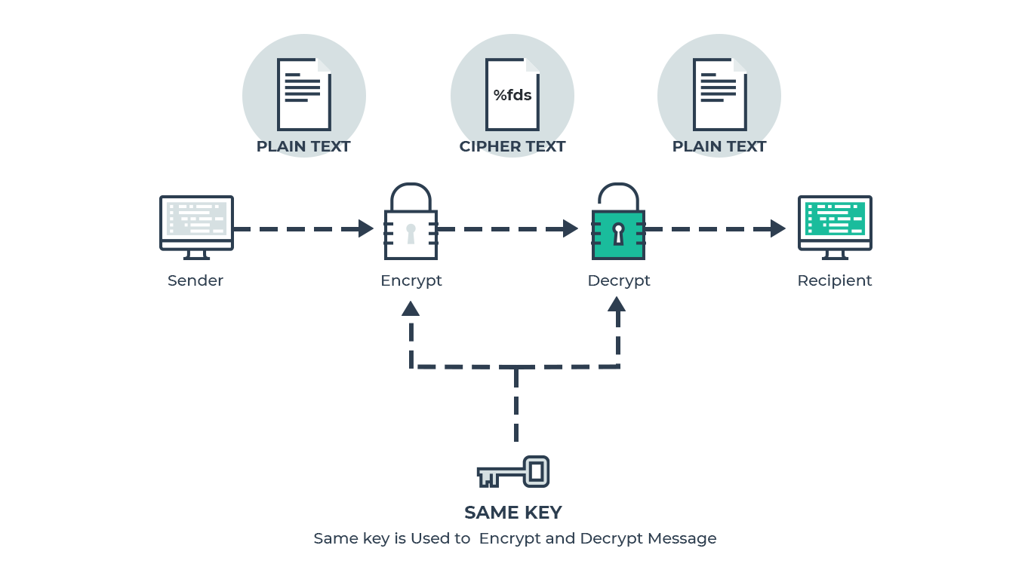

(Fig 8) Encryption and Decryption

**Security Algorithms Used**

**MD5 Algorithm**

## The [MD5 Message-Digest Algorithm](https://en.wikipedia.org/wiki/MD5) is a widely used [cryptographic hash function](https://en.wikipedia.org/wiki/Cryptographic_hash_function) that produces a 128-bit (16-byte) hash value. It’s very simple and straight forward; the basic idea is to map data sets of variable length to data sets of a fixed length.

In order to do this, the input message is split into chunks of 512-bit blocks. A padding is added to the end so that it’s length can be divided by 512. Now, these blocks are processed by the MD5 algorithm**,** which operates in a 128-bit state, and the result will be a 128-bit hash value. After applying MD5, generated hash is typically a 32-digit hexadecimal number.

Here, the password to be encoded is often called the “message” and the generated hash value is called the messagedigest or simply “digest**”**.

MD5 algorithm consists of 5 steps:

**Step 1. Appending Padding Bits**- The original message is "padded" (extended) so that its length (in bits) is congruent to 448, modulo 512.

**Step 2. Appending Length-** 64 bits are appended to the end of the padded message to indicate the length of the original message in bytes.

**Step 3. Initializing MD Buffer-** MD5 algorithm requires a 128-bit buffer with a specific initial value. The rules of initializing buffer are:

* The buffer is divided into 4 words (32 bits each), named as A, B, C, and D.
* Word A is initialized to: 0x67452301.
* Word B is initialized to: 0xEFCDAB89.
* Word C is initialized to: 0x98BADCFE.
* Word D is initialized to: 0x10325476.

**Step 4. Processing Message in 512-bit Blocks-** This is the main step of MD 5 algorithm, which loops through the padded and appended message in blocks of 512 bits each. For each input block, 4 rounds of operations are performed with 16 operations in each round.

**AES Algorithm**

AES is an iterative rather than Feistel cipher. It is based on ‘substitution–permutation network’. It comprises of a series of linked operations, some of which involve replacing inputs by specific outputs (substitutions) and others involve shuffling bits around (permutations).

Interestingly, AES performs all its computations on bytes rather than bits. Hence, AES treats the 128 bits of a plaintext block as 16 bytes. These 16 bytes are arranged in four columns and four rows for processing as a matrix. Unlike DES, the number of rounds in AES is variable and depends on the length of the key. AES uses 10 rounds for 128-bit keys, 12 rounds for 192-bit keys and 14 rounds for 256-bit keys. Each of these rounds uses a different 128-bit round key, which is calculated from the original AES key.

The features of AES are as follows −

* Symmetric key symmetric block cipher
* 128-bit data, 128/192/256-bit keys
* Stronger and faster than Triple-DES
* Provide full specification and design detail.

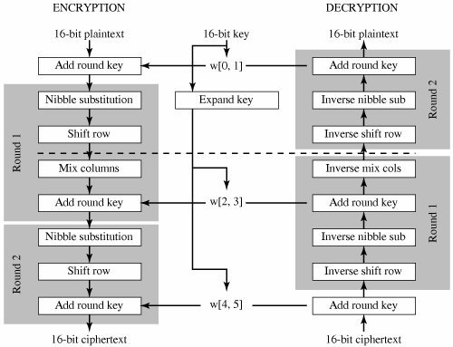

(Fig 9)

**SHA 512 Algorithm**

Secure Hash Algorithms, also known as SHA, are a family of [cryptographic](https://brilliant.org/wiki/cryptography/) functions designed to keep data secured. It works by transforming the data using a [hash function](https://brilliant.org/wiki/hash-function/): an algorithm that consists of [bitwise operations](https://brilliant.org/wiki/bitwise-operations/), [modular additions](https://brilliant.org/wiki/modular-additions/?wiki_title=modular%2520additions), and [compression functions](https://brilliant.org/wiki/compression-functions/). The hash function then produces a fixed-size string that looks nothing like the original. These algorithms are designed to be [one-way functions](https://brilliant.org/wiki/one-way-functions/?wiki_title=one-way%2520functions), meaning that once they’re transformed into their respective hash values, it’s virtually impossible to transform them back into the original data. A few algorithms of interest are SHA-1, SHA-2, and SHA-3, each of which was successively designed with increasingly stronger encryption in response to hacker attacks. SHA-0, for instance, is now obsolete due to the widely exposed vulnerabilities.

A common application of SHA is to encrypting passwords, as the server side only needs to keep track of a specific user’s hash value, rather than the actual password. This is helpful in case an attacker hacks the database, as they will only find the hashed functions and not the actual passwords, so if they were to input the hashed value as a password, the hash function will convert it into another string and subsequently deny access.

**SHA512 algorithm consists of following steps:**

* the message is broken into 1024-bit chunks,
* the initial hash values and round constants are extended to 64 bits,
* there are 80 rounds instead of 64,
* the message schedule array has 80 – 64-bit words instead of 64 – 32-bit words,
* to extend the message schedule array w, the loop is from 16 to 79 instead of from 16 to 63,
* the round constants are based on the first 80 primes 2 to 409
* the word size used for calculations is 64 bits long,
* the appended length of the message (before pre-processing), in bits, is a 128-bit big-endian integer, and
* the shift and rotate amounts used are different.

**INTRODUCTION TO PROJECT**

**Purpose**

This project aims at developing a webpage mail client that serve the user to send and receive mail. The existing user are needed to authenticate their identity and then they are permitted to check their mail in their mail box also they can send mail and can delete the necessary mail from mailbox. A good user interface has been provided for performing all these tasks easily. Security features such as Salting, hashing and encryption are also added to the data to enhance its security (On attributes as: Password, Message, etc).

**Project users:**

1. Admin can view the registered users
2. User can use the whole facility of internal mailing system

**Project modules:**

|  |  |
| --- | --- |
| Admin | User |
| Login  View user  Compose mail  Inbox  Sent mail  Delete mail  Sign out | Registration  Login  Compose mail  Inbox  Sent mail  Delete mail  Sign out |

(Table 2)

**Project Requirements:**

**Hardware requirement:**

Pentium processor       --------              233 MHZ or above

RAM Capacity            --------              128MB

Hard Disk                   --------              20GB

Operating System       --------              Window 7,8,10, XP, Linux.

**Software requirement:**

Web Presentation:HTML, CSS, Bootstrap, Angular4/TS

ProgrammingLanguage:Java

WebbasedTechnologies: Hibernate

Database Connectivity API:JDBC

Backend Database: Oracle

Server: Tomcat

IDEs: Eclipse with My Eclipse plugins/Visual Studio

Browser: Google Chrome

LOGIN

COMPOSE MAIL

INBOX



**USER**

SENT ITEMS

TRASH

ACCESS USERS

SIGN OUT

(Fig 10)

LOGIN

COMPOSE MAIL

INBOX



SENT ITEMS

TRASH

ACCESS USERS

SIGN OUT

(Fig 11)

**DATA FLOW DIAGRAM**

**Level 0**

Success/Error

MAILING SYSTEM

UName/Pass

Success/Error

USER

Manage User

ADMIN

*+++++*

(Fig 12.i)

**Level 1**

MAIL SERVER

USER

LOGIN

INTERNAL MAILING SYSTEM

AUTHENTICATION ON

REGISTER

USER FILE

(Fig 12.ii)

**Level 2**

TYPE MAIL

SEND MAIL

COMPOSE MAIL

USER

MAIL FILE

INBOX

SENT ITEMS

DELETE MAIL

TRASH

(Fig 12.iii)

**Database Model**

**ER Diagram**

USER

SECURITY ANS

SECURITY QUES

NAME

ATYPE

FNAME

DOB

LNAME

USERNAMEEE

PASSWORD

RECEIVER ID

DATE

CAN

s

VIEW

PASSWORD

LOGIN

SENT ITEMS

EMAIL ID

COMPOSE MAIL

TO

FROM

MESSAGE

SUBJECT

INBOX

SUBJECT

RECEIVER ID

TRASH

SENDER ID

SUBJECT

DATE OF DELETION

DATE

SUBJECT

SENDER ID

(Fig 13.i) **User**

ADMIN

PASSWORD

EMAIL ID

ACCESS

CAN

LOGIN

PHONE NO.

TO

UNAME

COMPOSE MAIL

USER DETAILS

DATE OF ACC. CREATED

FROM

SUBJECT

VIEW

NAME

MESSAGE

INBOX

SENDER ID

DATE

SUBJECT

DATE

SENT ITEMS

RECEIVER ID

SUBJECT

TRASH

SUBJECT

DATE OF DELETION

RECEIVER ID

SENDER ID

(Fig 13.ii) **Admin**

**Data Dictionary**

**User’s DataBase**

|  |  |  |  |
| --- | --- | --- | --- |
| **FIELD** | **DATA TYPE** | **NULL/NOT NULL** | **DESCRIPTION** |
| UserName | Varchar2 | Not Null | Primary Key |
| Role | Varchar2 | Not Null |  |
| Password | Varchar2 | Not Null |  |
| FName | Varchar2 | Not Null |  |
| LName | Varchar2 | Null |  |
| Dob | Date | Not Null |  |
| Gender | Varchar2 | Not Null |  |
| Phone Number | Varchar2 | Null |  |
| Security Question | Varchar2 | Not Null |  |
| Answer | Varchar2 | Not Null |  |
| Doac | Date | Not Null |  |
| Result | Varchar2 | Null |  |
| Salt | Clob | Not Null |  |

(Table 3)

**Content DataBase**

|  |  |  |  |
| --- | --- | --- | --- |
| **FIELD** | **DATA TYPE** | **NULL/NOT NULL** | **DESCRIPTION** |
| Email Number | Number | Not Null | Primary Key |
| Sender Id | Varchar2 | Not Null |  |
| Receiver Id | Varchar2 | Not Null |  |
| Subject | Varchar2 | Not Null |  |
| Dos | Date | Not Null |  |
| Message | Clob | Not Null |  |
| RAct | Varchar2 | Null |  |
| SAct | Varchar2 | Null |  |
| Result | Varchar2 | Null |  |
| Dod | Date | Null |  |
| Dopd | Date | Null |  |

(Table 4)

**SCREENSHOTS**

**USER MODULE**

**1. HOME PAGE:**



**2.REGISTER PAGE:**

**(a) Validations**

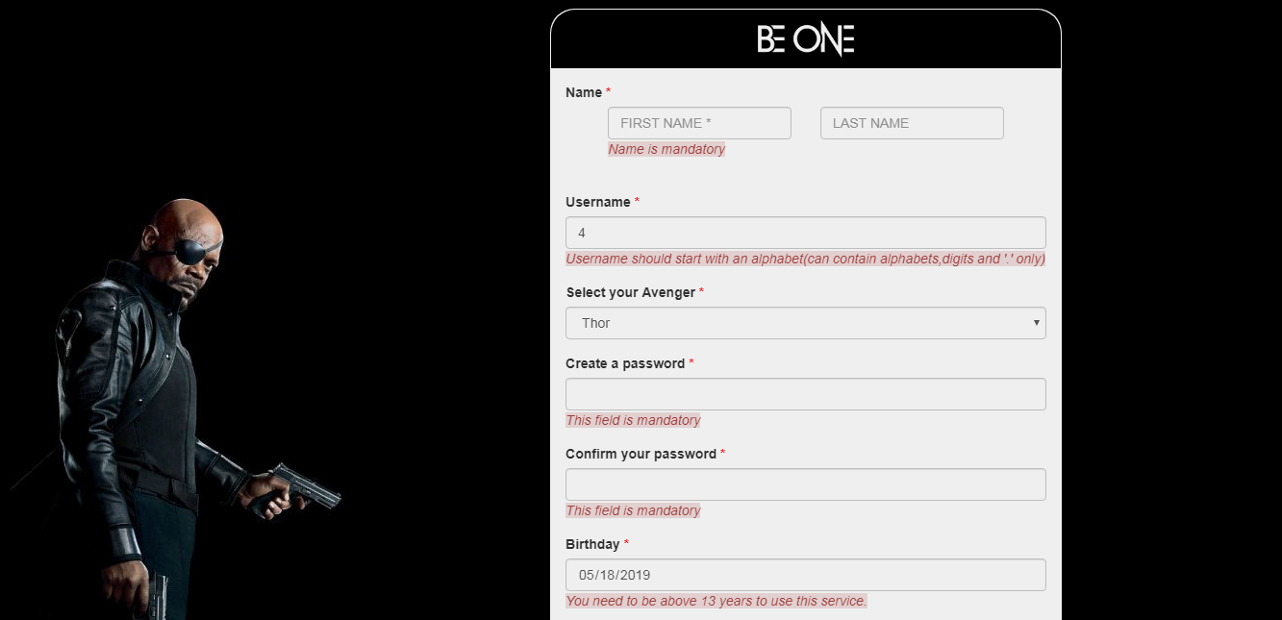

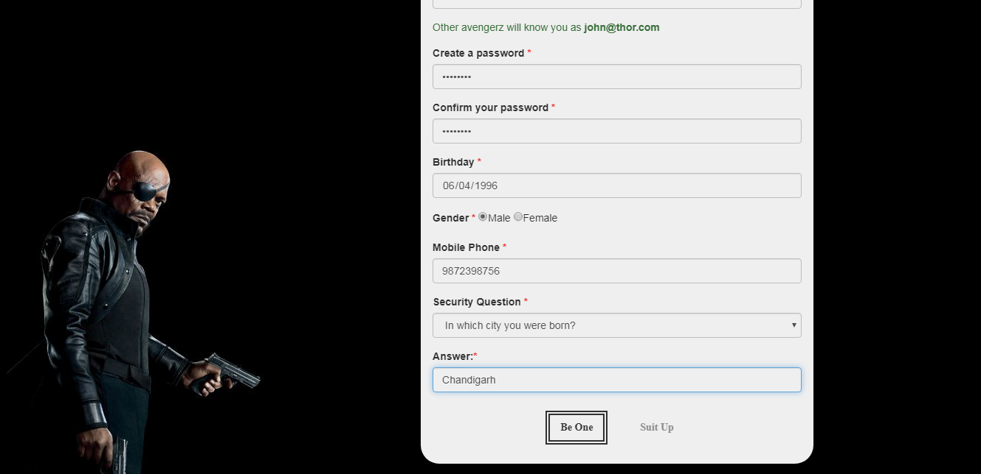

**(b) Successful registration with success message from backend**

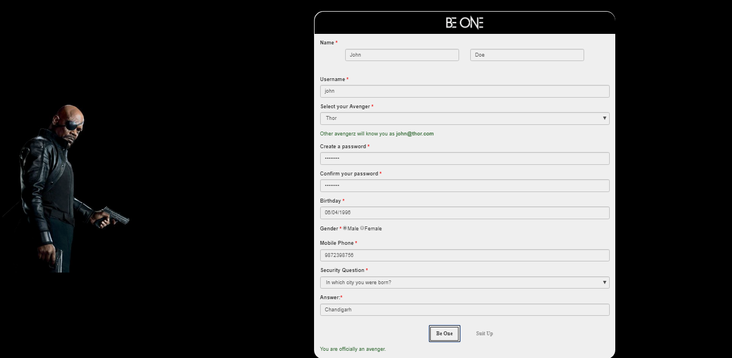

**3.LOGIN PAGE:**

**(a) Validations**

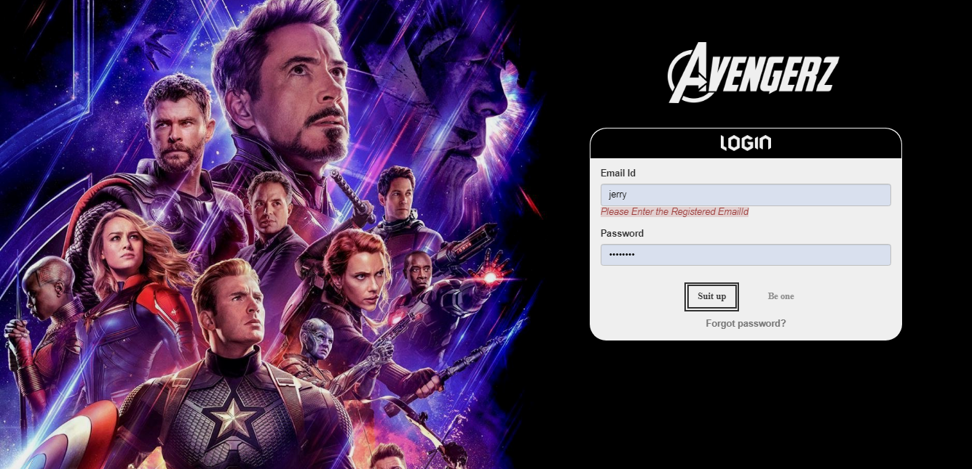

**(b) Disable functionality after 3 wrong password attempts**

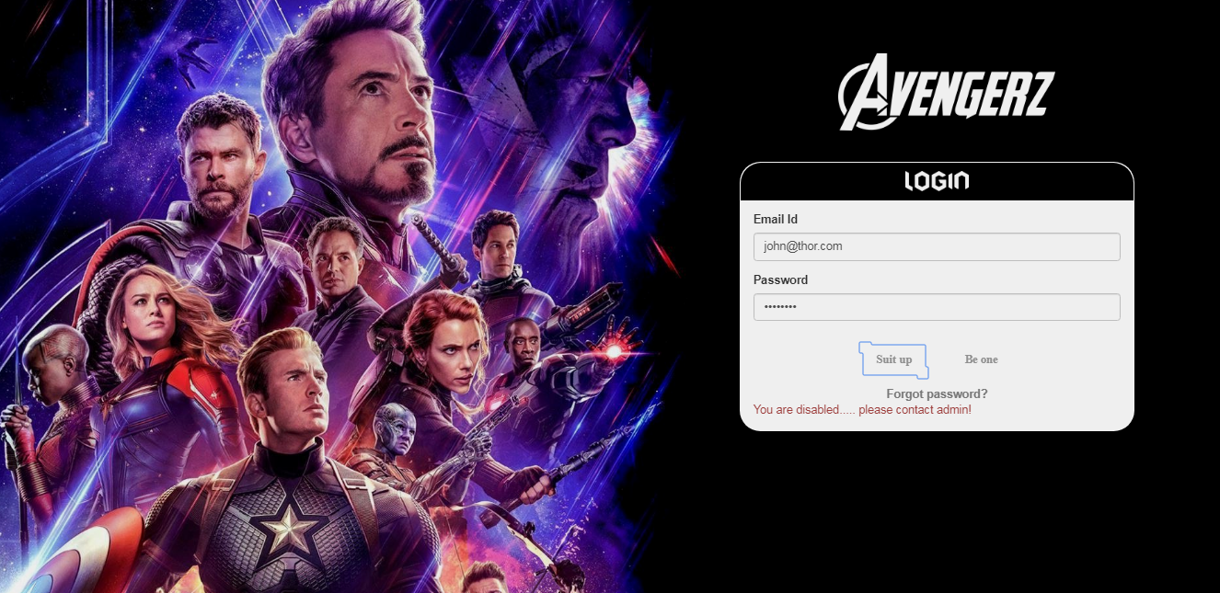

**4.FORGOT PASSWORD**

**(a) When account is disabled**

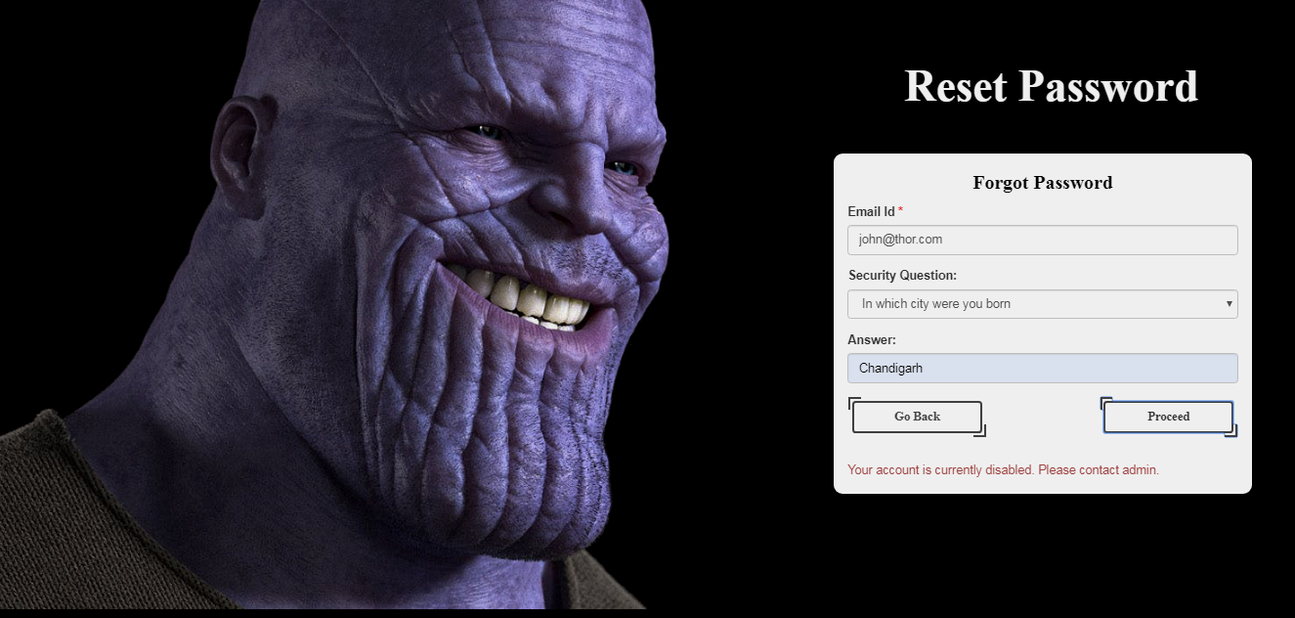

**(b) Before proceeding to reset password**

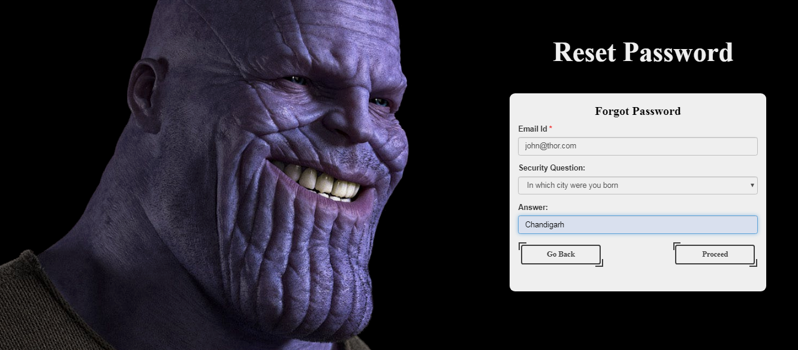

**4. RESET PASSWORD FORM**

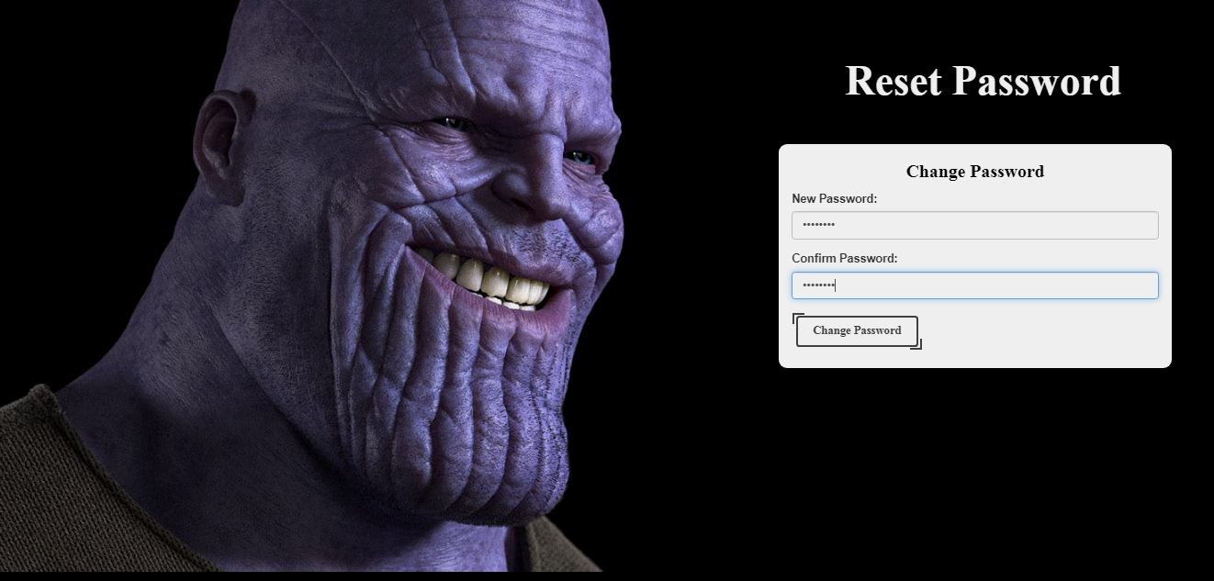

**5.AFTER LOGIN PAGE:**

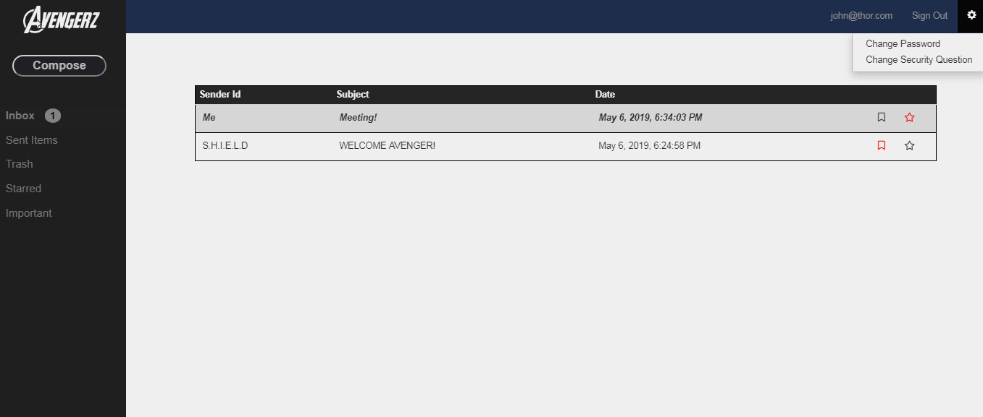

**5.COMPOSE MAIL (Error message):**

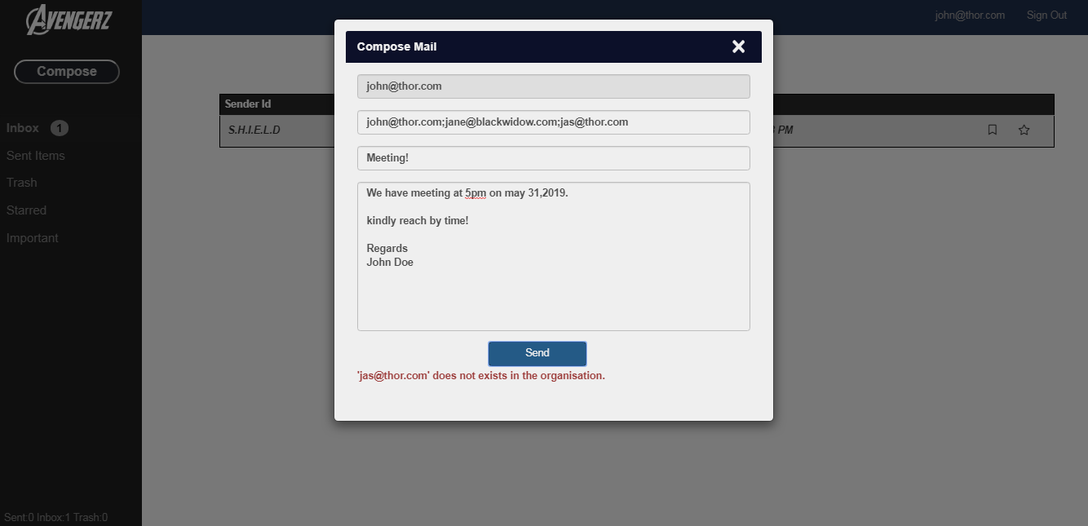

**6.COMPOSE MAIL (Succesful message):**

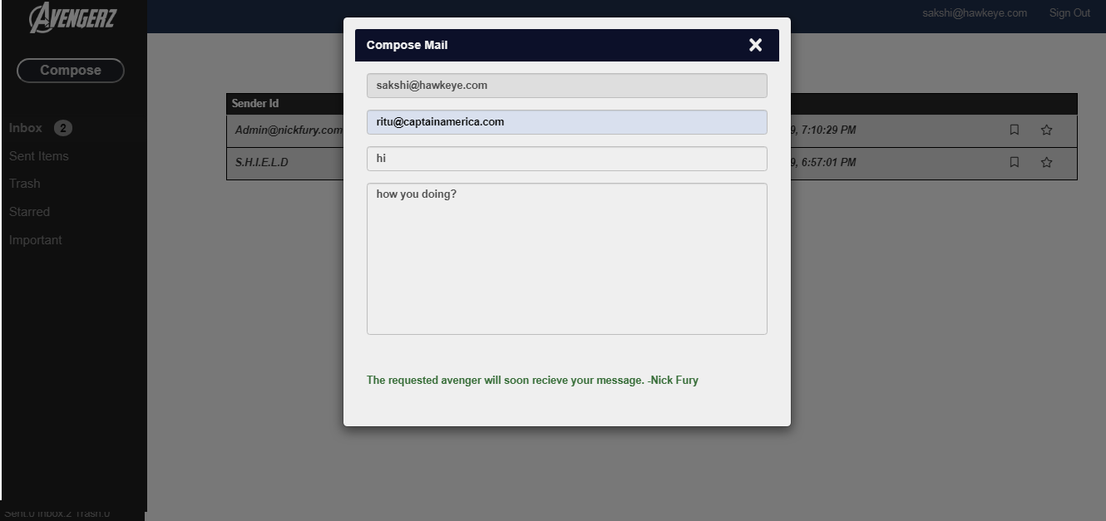

**7.READ/UNREAD FEATURE:**

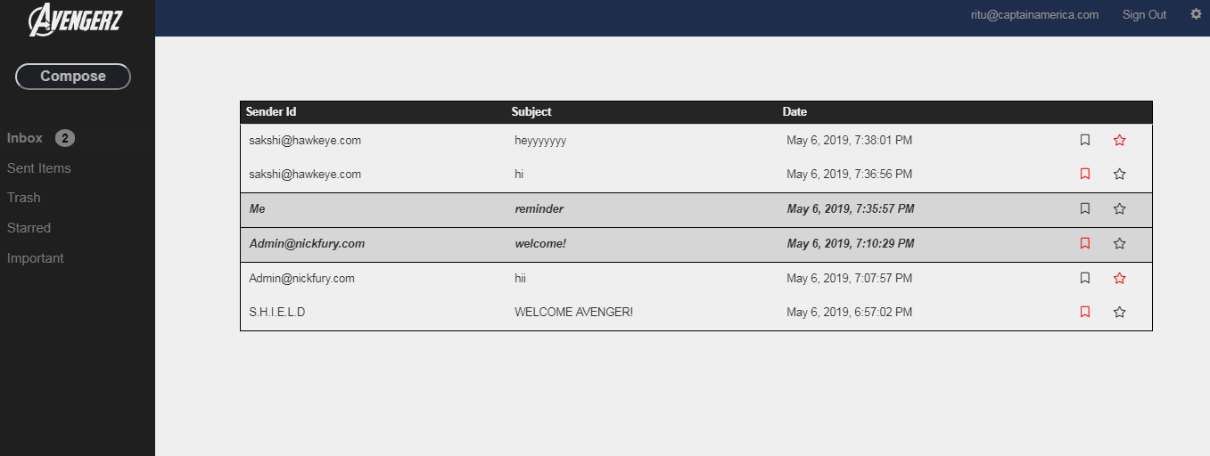

**8.DISPLAY MESSAGE:**

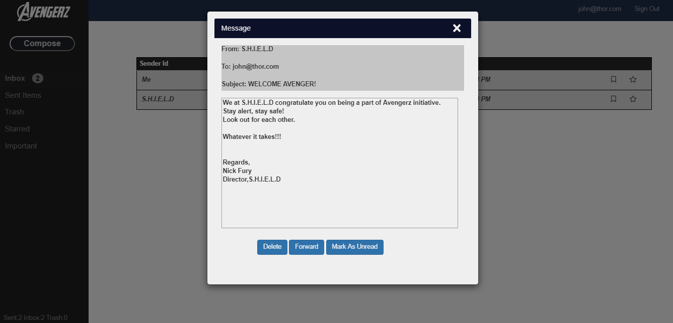

**9.SENT ITEMS:**

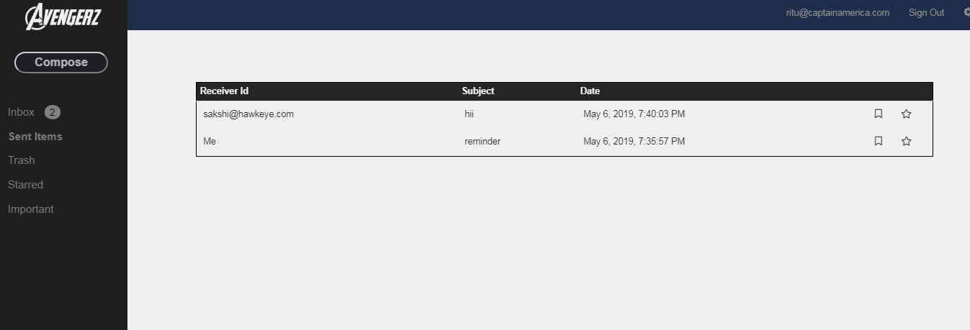

**10.TRASH:**

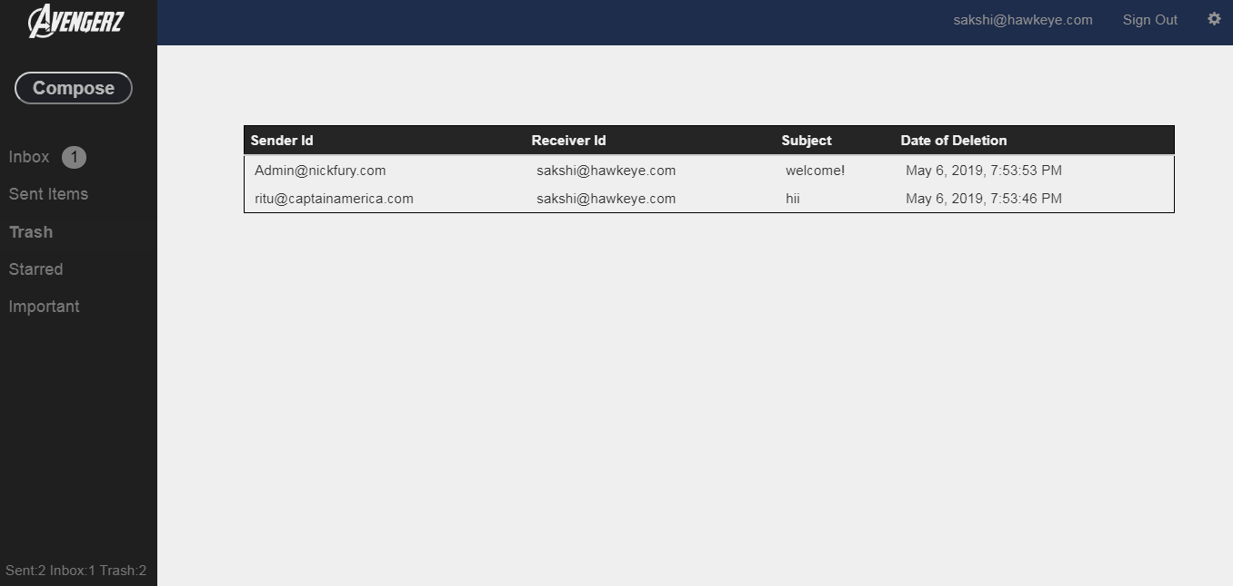

**11.FAVOURITE/STARRED:**

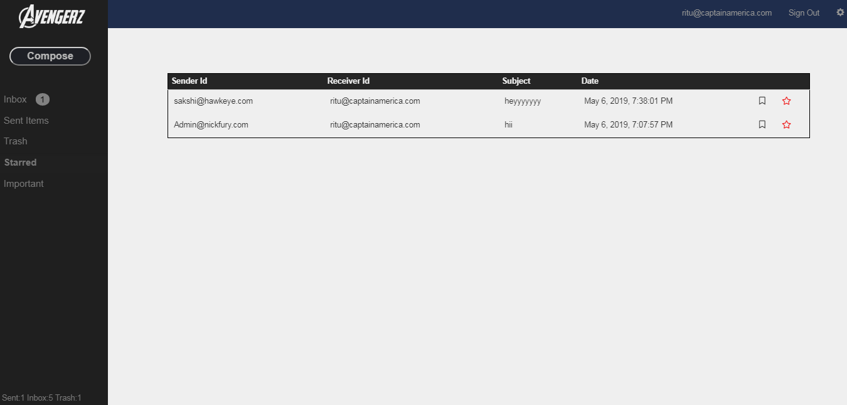

**12.MARK IMPORTANT:**



**13.FORWARD MAIL:**

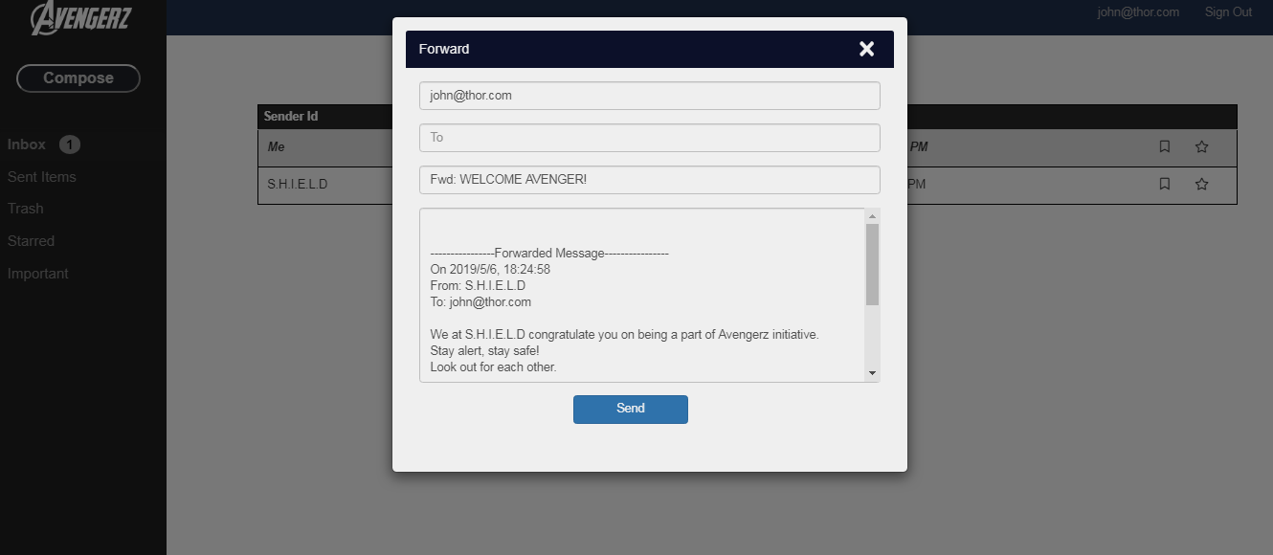

**14.REPLY MAIL:**

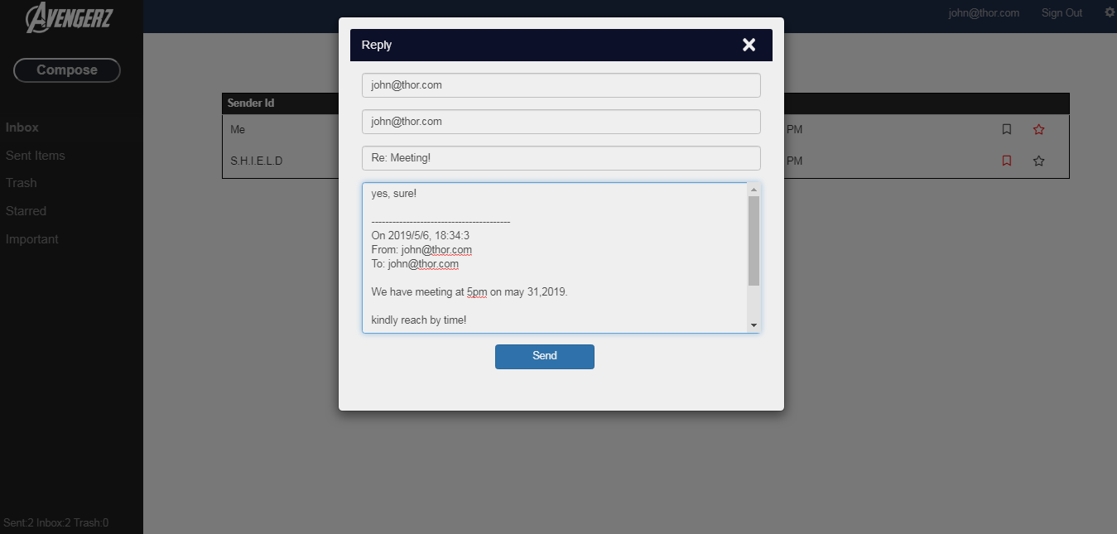

**15.NO MAIL PRESENT:**

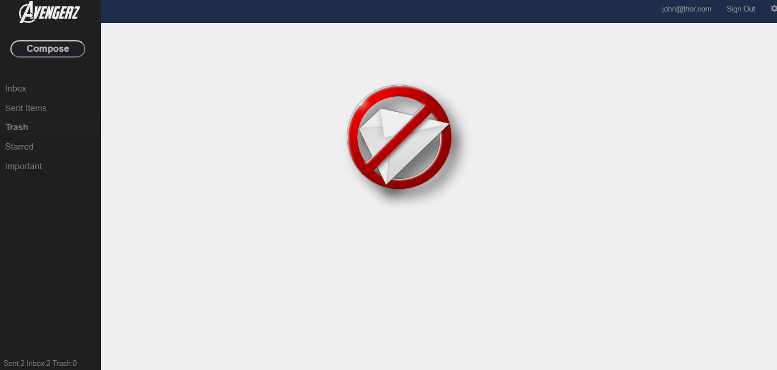

**16.USER SETTINGS**

**(a) Change current password:**

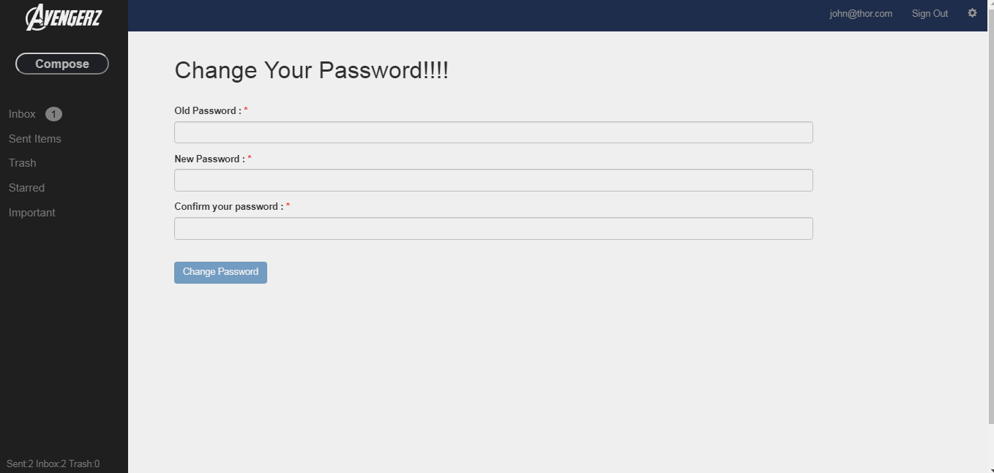

**(b) Change security question:**

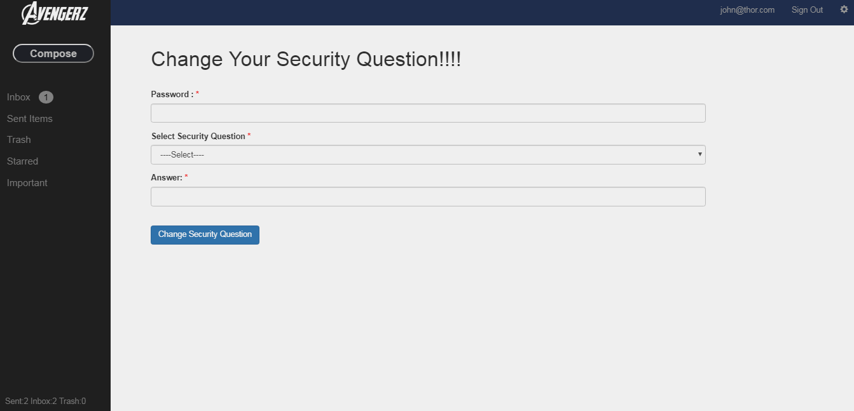

**ADMIN MODULE**

**1.HOME PAGE**



**2.AFTER LOGIN PAGE:**

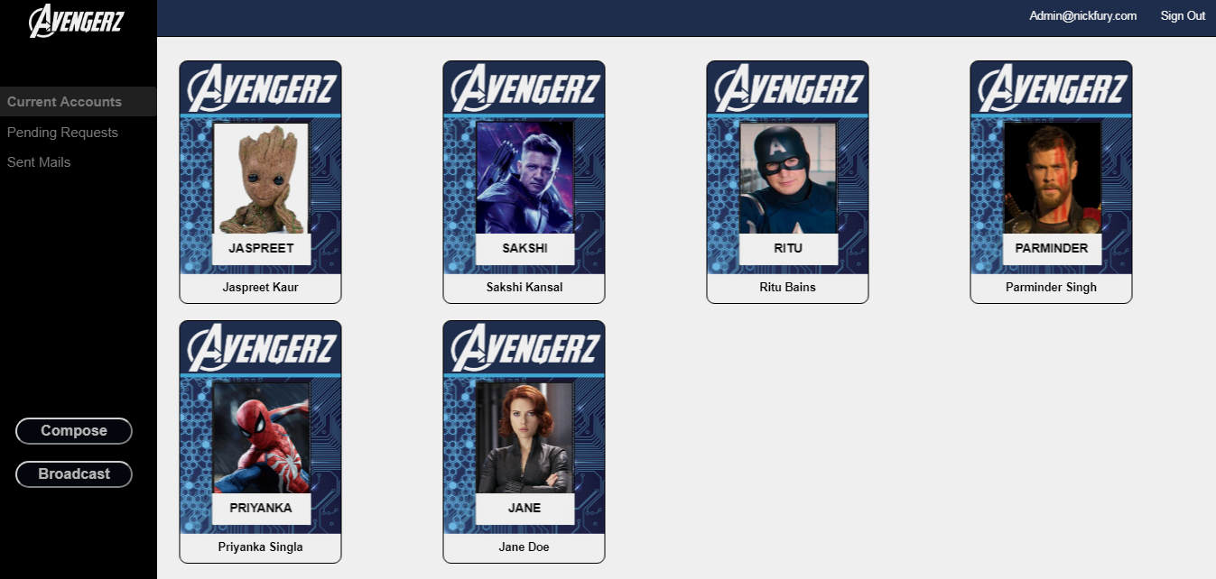

**3.FLIP CARD FUNCTIONALITY**

**(Delete user, disable user, send mail, view inbox of user):**

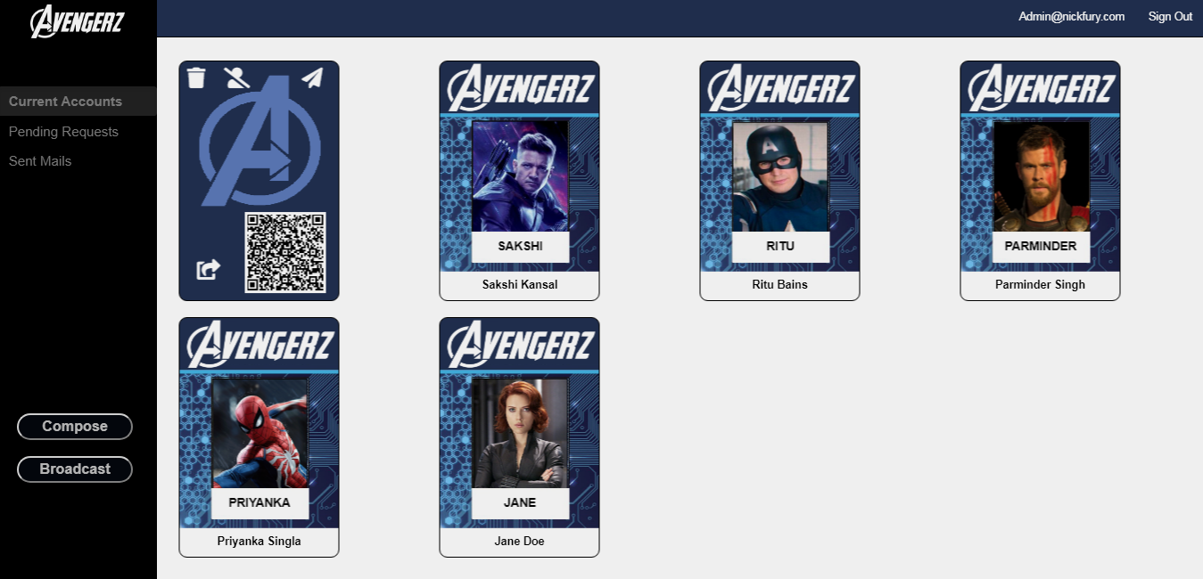

**(b) QR Code Functionality:**

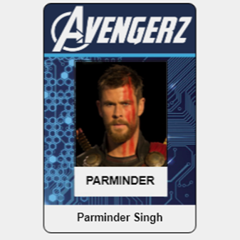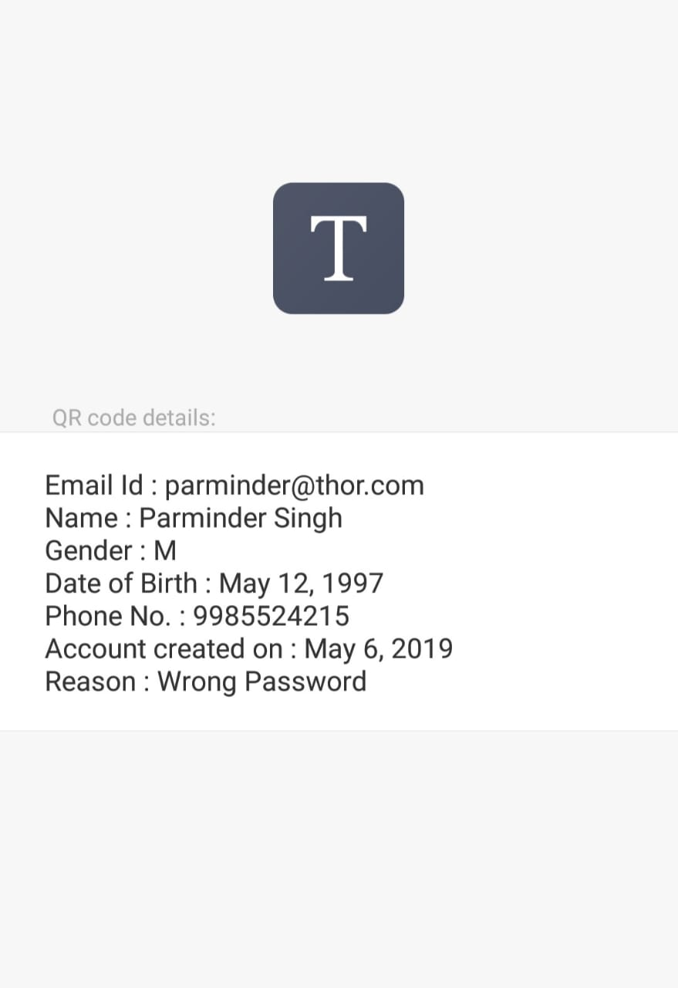

FRONT SIDE

SCANNING

**4.USERS STATUS:**

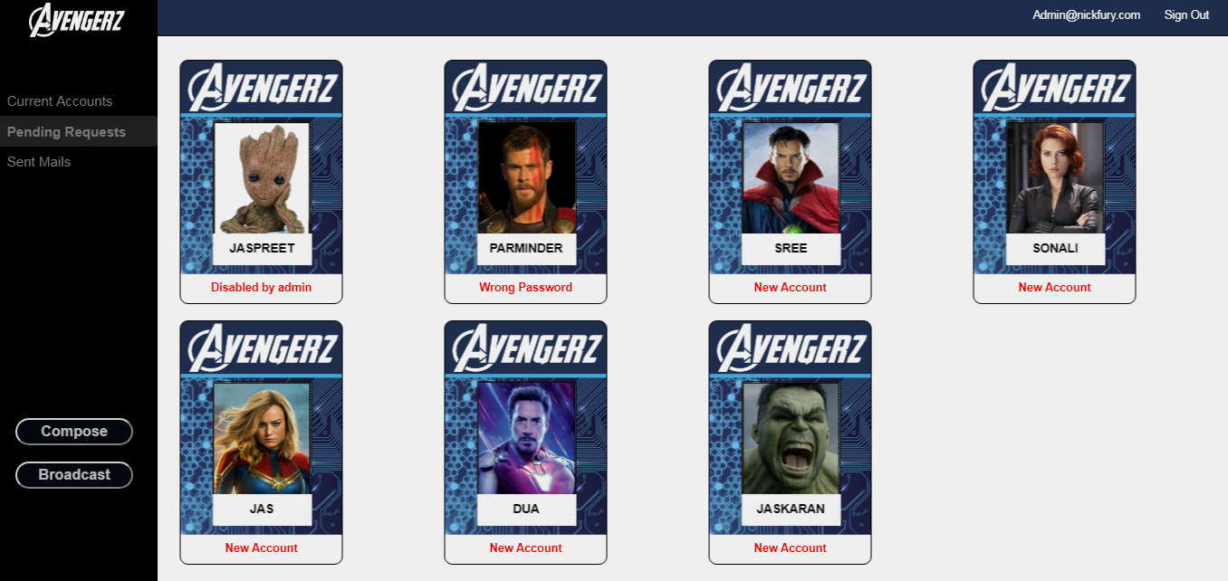

**5.ADMIN COMPOSE PAGE:**

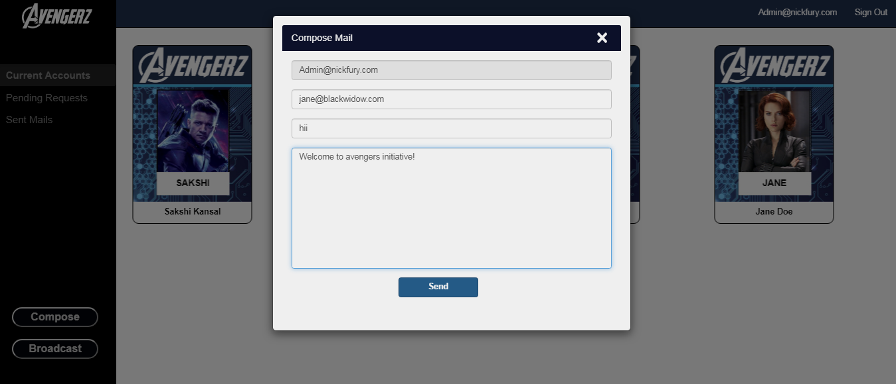

**6.SENT MAILS:**

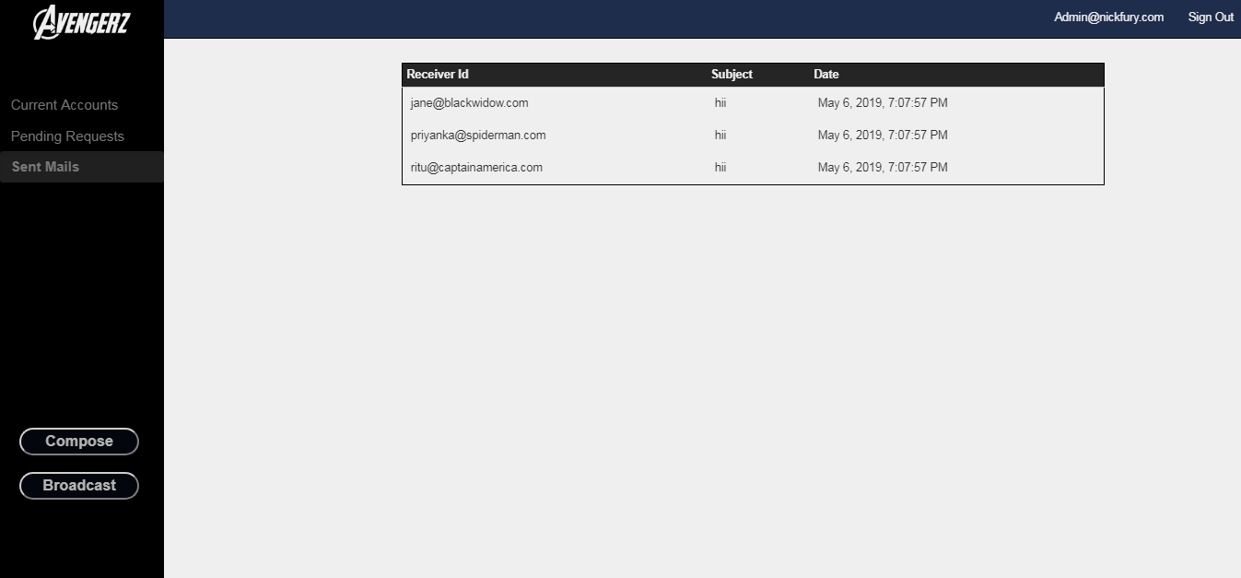

**7.BROADCAST MAIL (All Users):**

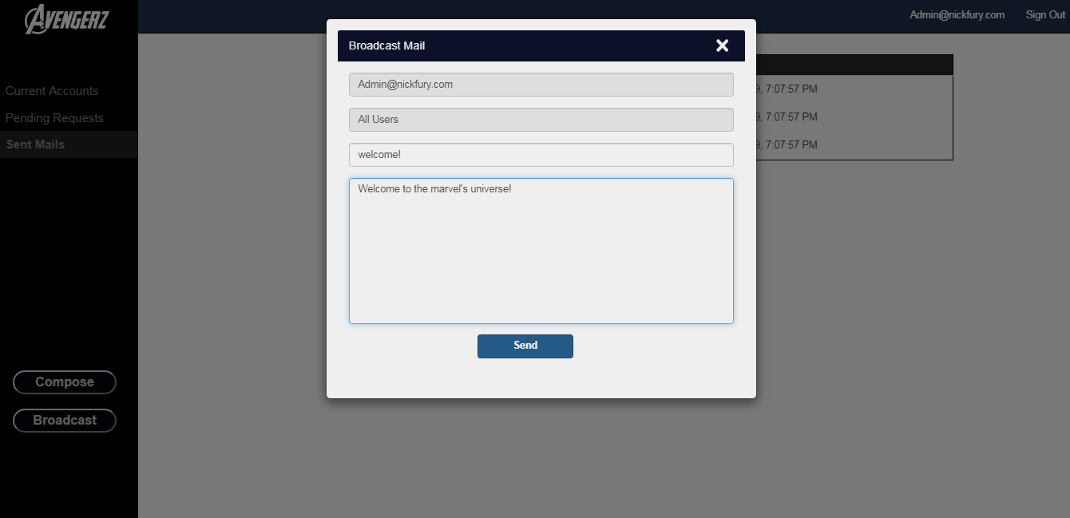

**8.VIEW MAIL BOX OF USER>> Permanently deleted mails:**

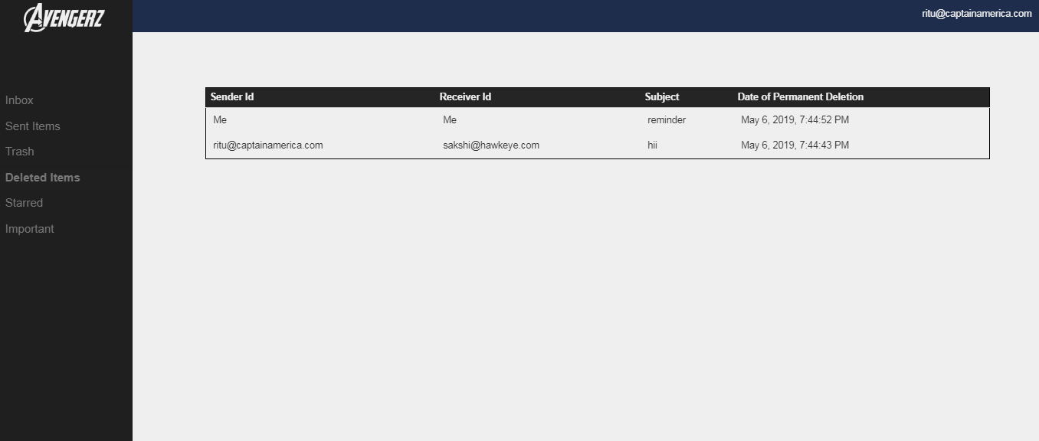

**WRONG PAGE ERROR:**

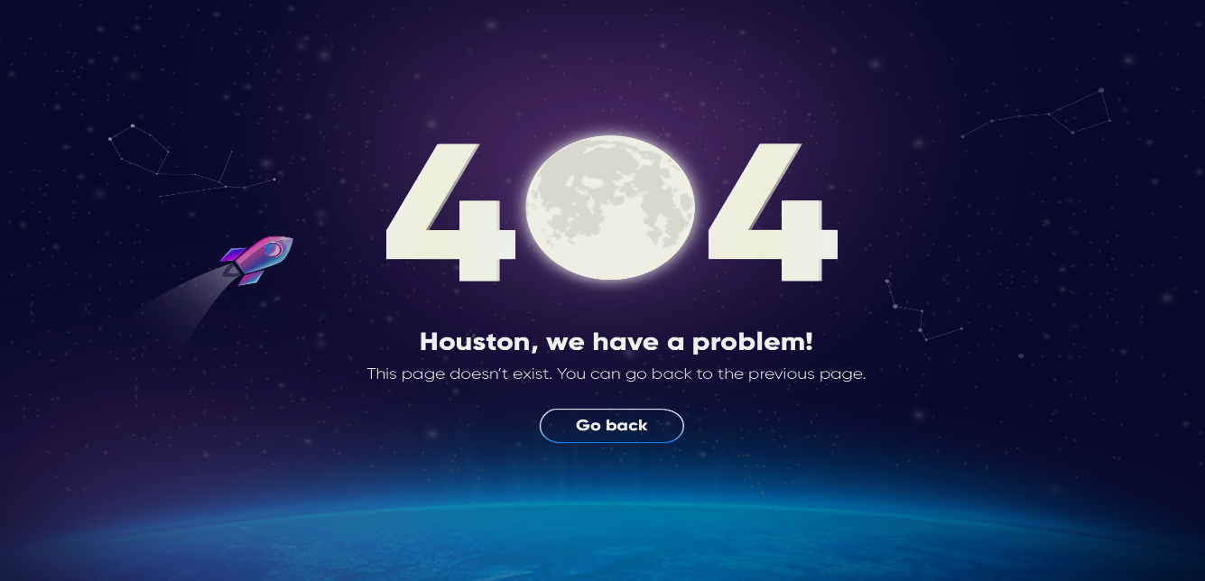

**The Collaboration with movie booking project:**

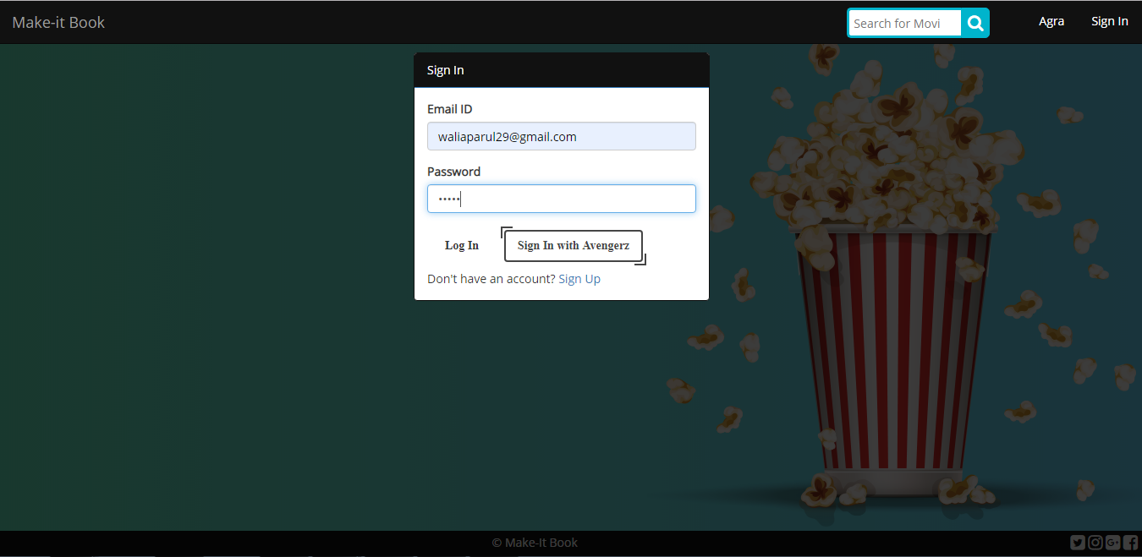

**After booking, the mail received:**

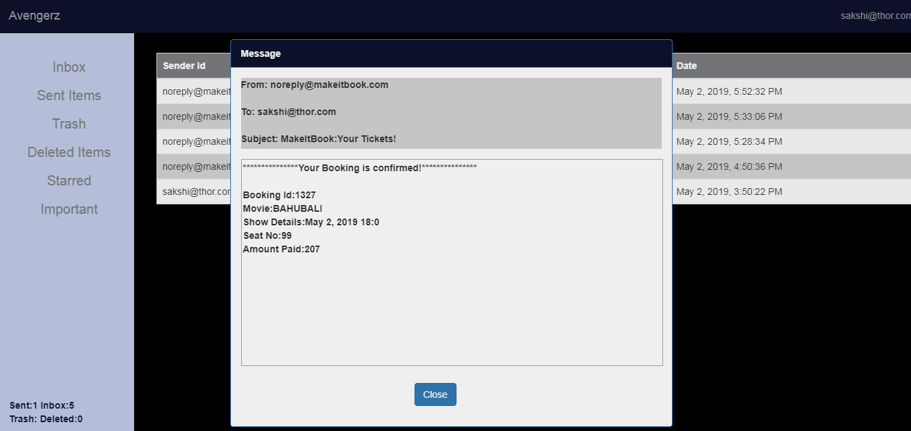

**CONCLUSION**

Earlier, when mailing system was not available, postal system and telephone were the most omnipresent means to spread out notices. This was a very tedious, uneconomical, and time consuming task for consultancy offices. But, with the inception of email, the traditional system has gone obsolete.

And to solve the above problems, the new system proposed is used to solve the mentioned problems. Organisation who are largely in need of a proper mailing list management system, can use this application to use it within organisation for internal mailing system between users and between user and admin . This can also be used to broadcast emails to users to notify them about some important event/details.

The proposed system is that mailing lists can be created in the system database. This allows administrators to view available list of mailing addresses along with user profiles from the back end.

The proposed system have unique theme and interactive user interface. The flipping card functionality is used to list the users which make the interface interactive. Further, QR code functionality adds more into features. The user can also compose mail to multiple users at a time. The passwords, phone Number, security answer are stored in hashed format whereas the subject and the body of the mail are stored in encrypted form in the backend which makes the system secure. In nutshell, there are many new and interactive features in the proposed system which make it efficient, secure, interactive and advantageous.

**MAJOR CONTRIBUTIONS**

Registration page and login page frontend coding- Parminder Sidhu and Jaspreet Kaur

Forget password and reset password frontend coding- Sonali and Jaskaran Kaur

Admin page Login – Jaskaran Singh and Parminder sidhu

Admin compose mail, sent mail, view inbox and broadcast- Shubham Dua and Jaspreet kaur

User compose, reply, forward, Mark imp n favourite- Shubham Dua, Sonali, Jaskaran Kaur

User Settings- Sonali, Jaspreet kaur

Validations- Shubham Dua, Jaspreet Kaur,Sonali

Backend Hashing, Salting and Encryption- Jaskaran Singh, Jaskaran Kaur

Backend API’s, service and DAO- Jaskaran Singh, Shubham Dua, Jaspreet kaur

**INDIVIDUAL CONTRIBUTIONS/IDEAS**

Usage of cards, QR Code and salting- Jaskaran Singh

Combining the mail system to another project- Shubham Dua

Broadcast mail – Jaspreet kaur

Error Page – Sonali

Multiple sends- Jaskaran Kaur

Theme of the project- Parminder Sidhu

Every individual worked as a equal member of the team. The refactoring of the team helped in making the project a complete success within the time range. The overall team mentality was “Think ‘we’ not ‘me’”. Every team member was respectful, approachable and helping. The positive vibes created positive environment in which every mate was comfortable and it let everyone to contribute effectively.

**BIBLIOGRAPHY/REFERENCES**

* 1. Study course in the company (Interactive Learning Programs)
  2. http://www.w3schools.com/
  3. <https://www.quora.com/>
  4. <https://stackoverflow.com/>
  5. <https://www.slideshare.net/>
  6. http://www.geekforgeeks.org/